Bath Spa Counts

Staff and Student Diversity Data 2020/21
If you need Bath Spa Counts in a different format, please contact: the Equalities Officer Megan Robertson on m.robertson3@bathspa.ac.uk.

1.0 What is Bath Spa Counts?
1.1 This booklet contains a snapshot of Bath Spa’s staff and student data for the academic year 2020/21.
1.2 Staff data is taken from data supplied via MyHR. Comparator data is taken from the Higher Education Statistics Agency (HESA) and includes data from: Chichester, Falmouth, Gloucestershire, Goldsmiths, Lincoln, Oxford Brookes, and Winchester Universities. Sector data and student data is also taken from HESA.

2.0 Staff Gender
2.1 All Staff Gender
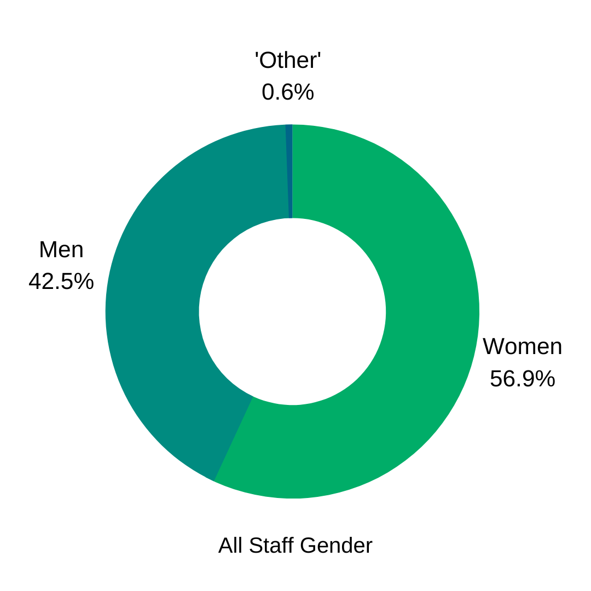
2.2 At Bath Spa in the year 2020/21, 56.9% identified as women, 42.5% men, 0.6% 'other' which is aligned to the BSU comparator groups.

2.3 This year senior roles held by women decreased to 46.6%. Other comparator groups have remained stable over the past year, so despite the decrease, BSU’s percentage of women in senior roles is now slightly above all comparator groups.
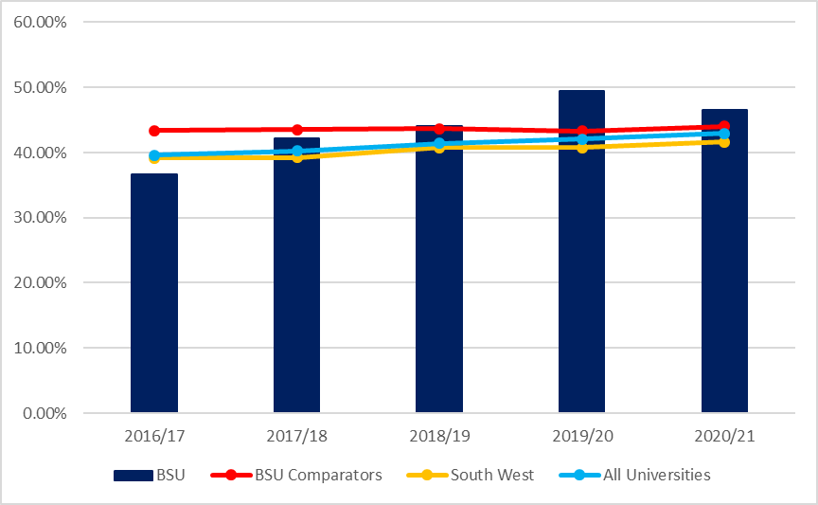

2.4 50.0% of our professorial staff identified as women. Sector-wide is at 28.5% women, South West HEIs at 31.7%, and our comparator group at 37.7%.

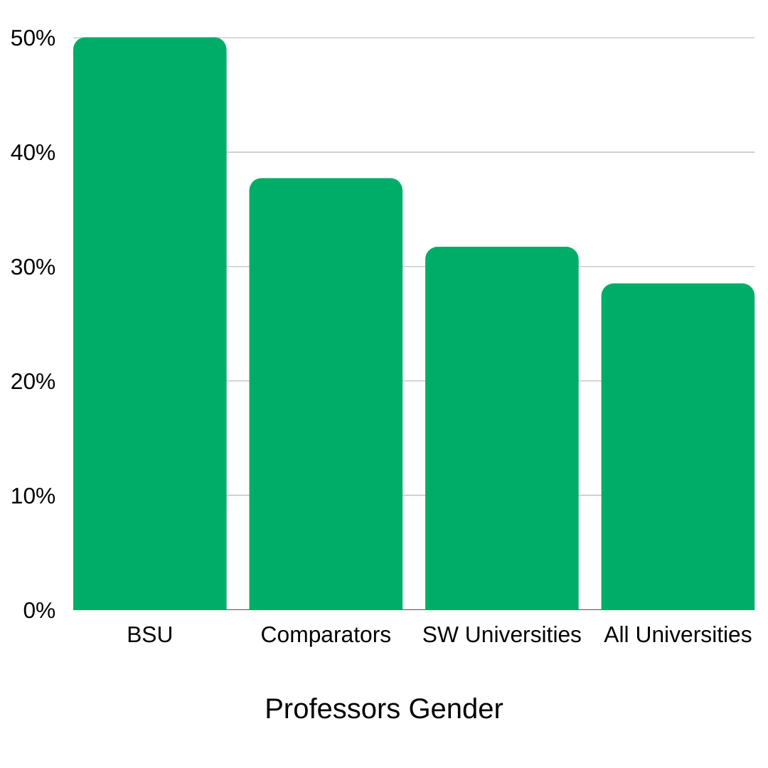
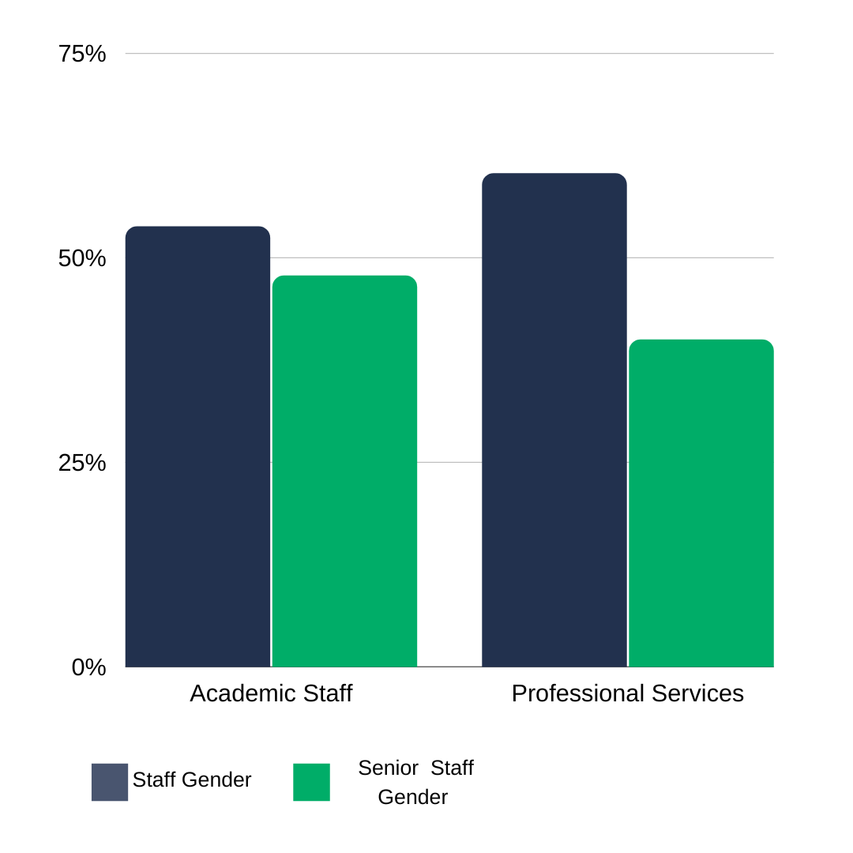
2.5 Of BSU Academic staff, 53.8% identify as women, of BSU Senior Academic staff its 47.8% women. Of our Professional Service staff, 60.3% identify as women. Of our professional service senior staff, 40% identify as women. This is based on a small population of just 10 individuals, however.

3.0 Gender Pay Gap
3.1 The mean average gender pay gap at Bath Spa University is 9.8%, equivalent to £2 per hour. The median gender pay gap is 11.1% equivalent to £2.26 per hour. In 2020, these figures were 11.2% and 18.6% respectively, showing a further narrowing of the gender pay gaps.
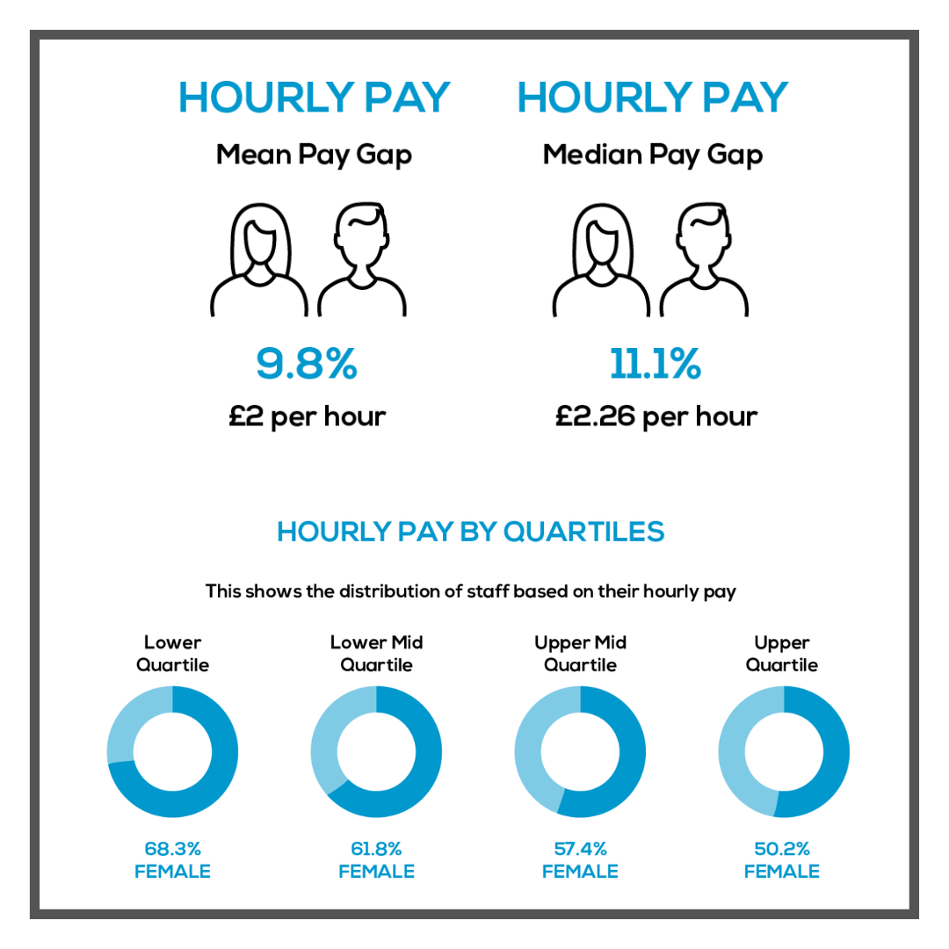

4.0 Staff Ethnicity Data
4.1 All staff Ethnicity Data: Staff who identified as Black, Asian, or another minoritised ethnicity (abbreviated to BAME for this report) has increased in 2020/21 by 7.7%.The BSU comparator group is 14.1%, South West universities at 10.2%, and all universities at 15.1%.
4.2 There is widespread criticism of the usage of ‘BAME’, one of the reasons being that it can obscure challenges concerning the representation of specific groups, such as the sector-wide underrepresentation of Black staff.

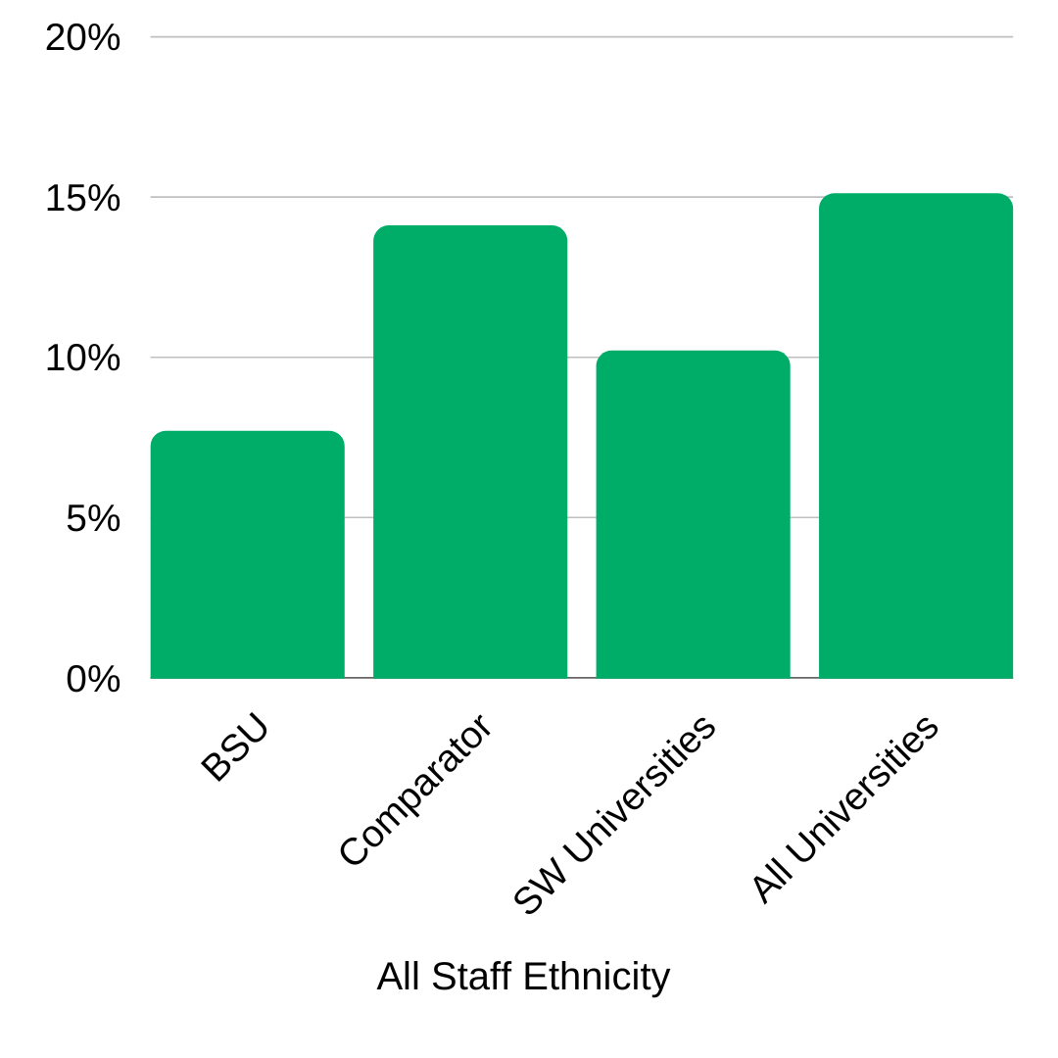
4.3 The proportion of all BSU staff identifying as Black and BAME in 2020/21 was 0.8%, compared to the sector figure of 2.7%.

4.4 Senior Staff Ethnicity: 8.1% of our senior staff identified as BAME. The BSU comparator group is at 7.9%, South West universities at 6.5%, and all universities at 7.3%.

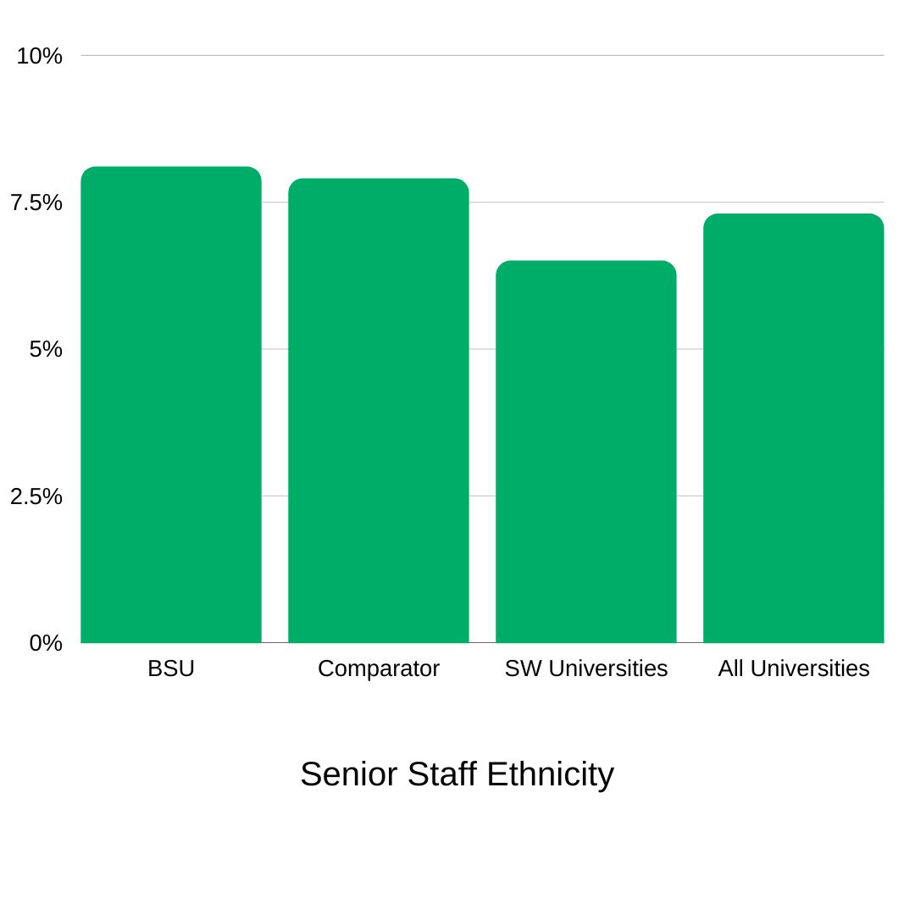
4.5 Academic staff in the BAME group has increased to 9.9%. Comparator group at 13.8%, South West universities at 13.3%, and all universities at 17.3%.
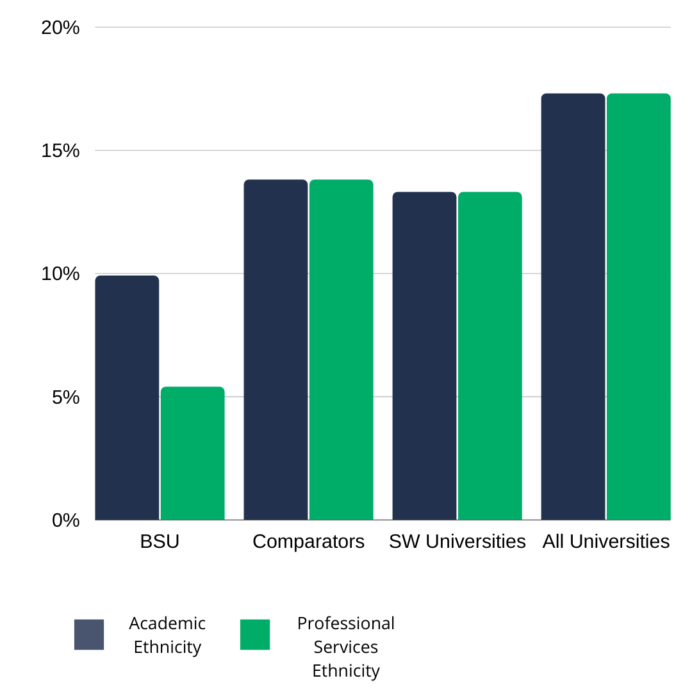
4.6 Professional Services staff in the BAME group has increased to 5.4% from 5.2%. This is significantly lower than the BSU comparator group at 13.8%, South West universities at 13.3%, and all universities at 17.3%.

5.0 Staff Disability Data
5.1 All Staff:
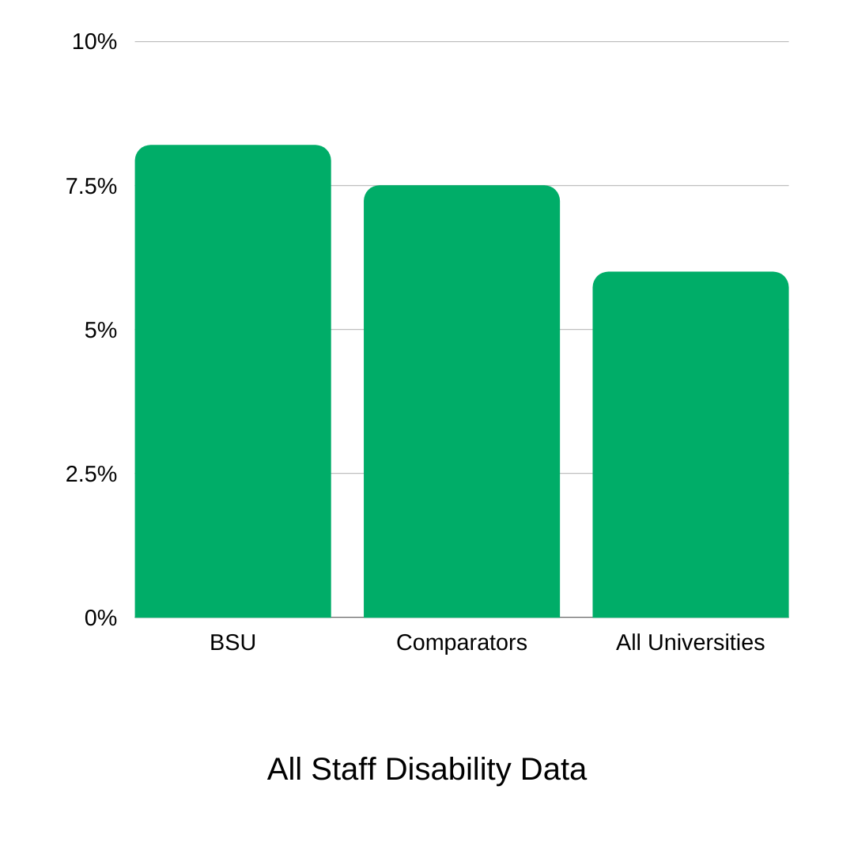
8.2% of staff self-identify as disabled in 2020/21. This remains higher than the BSU comparator group at 7.5%, and all Universities at 6.0%

5.2 Senior Staff: 3.2% of our senior staff self-identify as disabled in 2020/21. Our BSU comparator group is at 4.2% and all Universities at 4.0%.

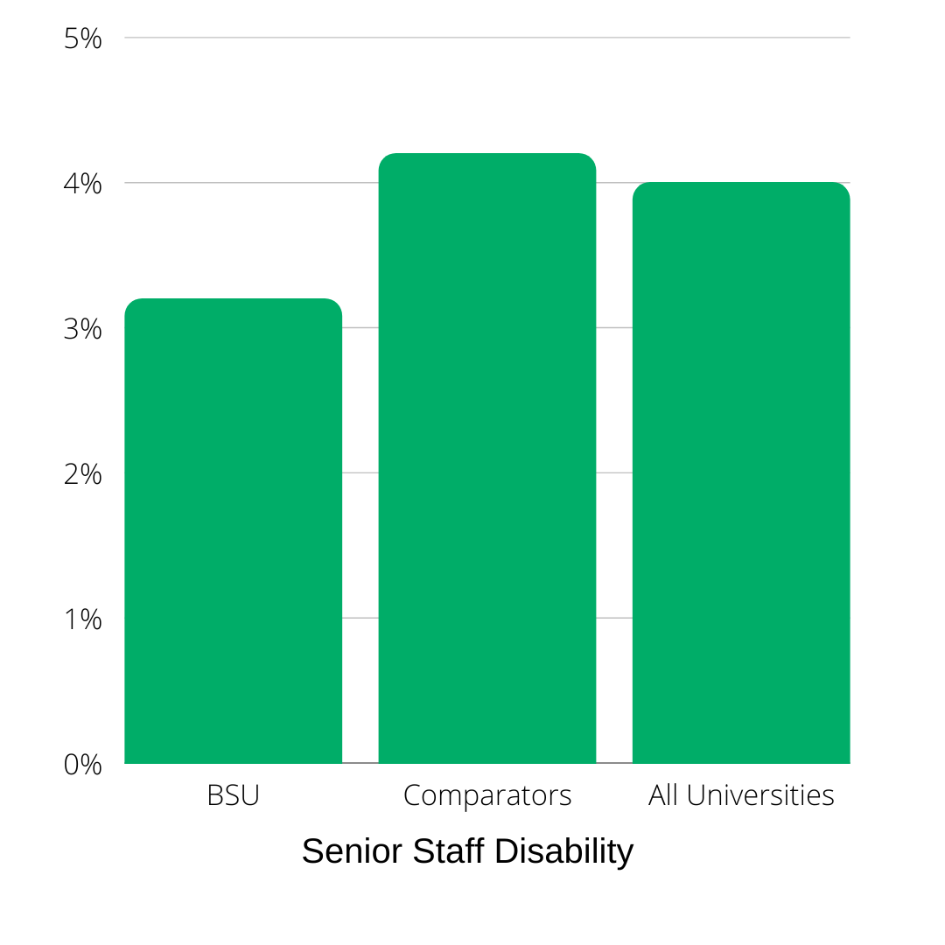
5.3 Academic and Professional Services Disability: 5.6% of Academic staff self-identify as disabled. The BSU comparator group is at 6.9%, and all universities are at 5.1%. Professional service staff that self-identify as disabled is at 11.1%. The BSU comparator groups at 8.5%, and all universities at 7.0%.

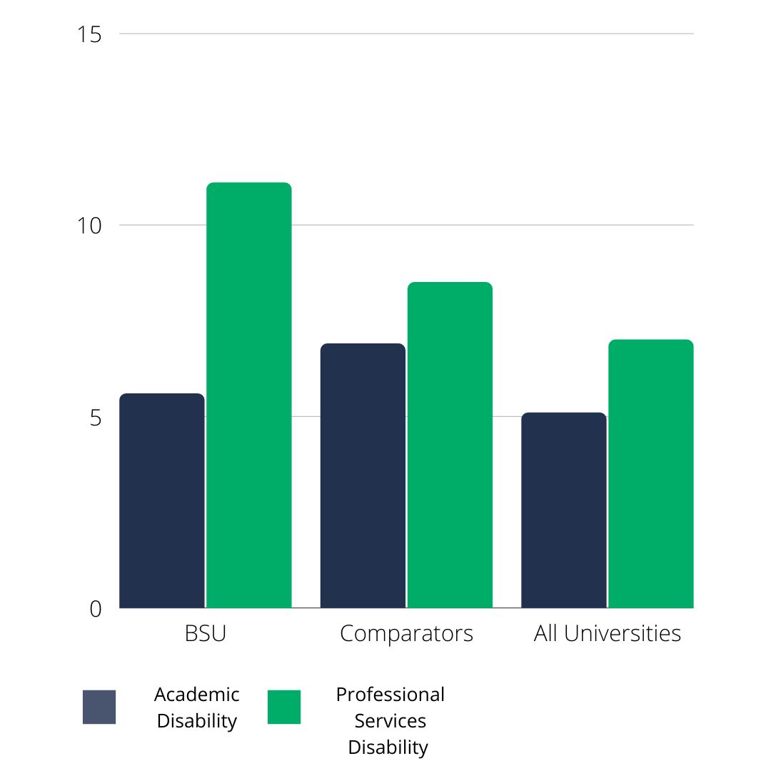

6.0 Staff Age Data
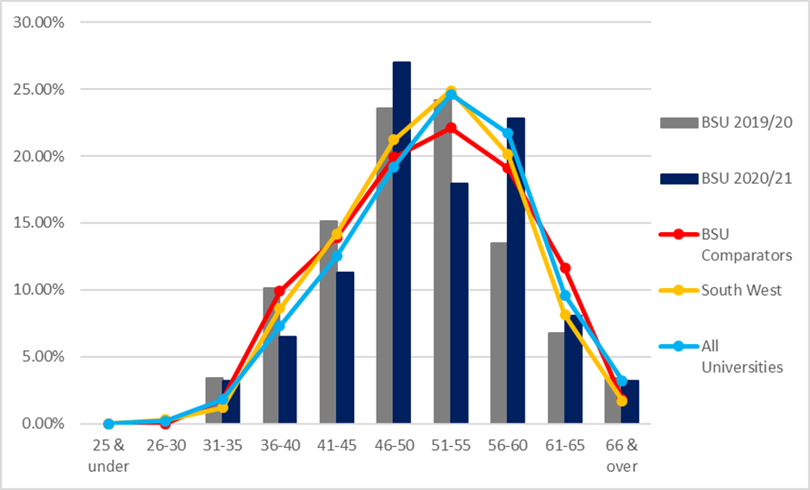
6.1 All Staff: The percentage of BSU staff aged 40 and under is generally lower than the benchmarks, and the proportion of staff between 46-60 is higher than all benchmarks, with a significant peak in the 46-50 age bracket.

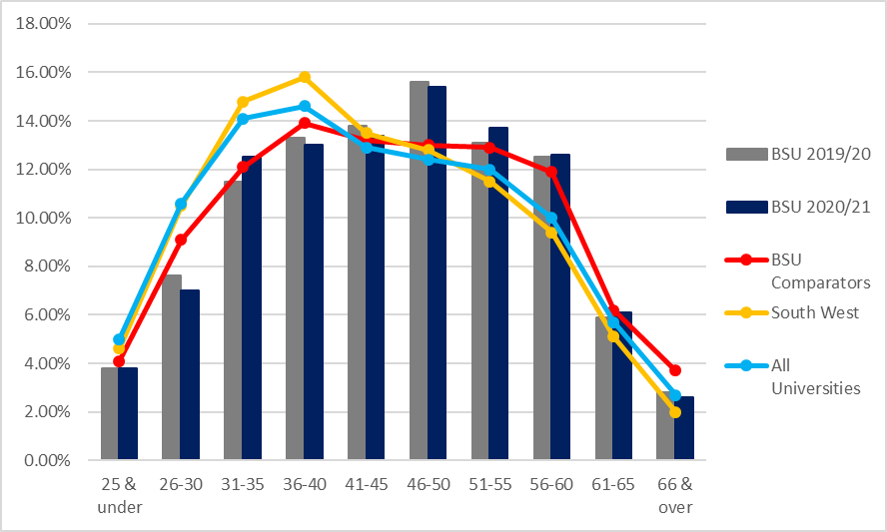
6.2 Senior Staff: For senior staff at BSU, the proportion of staff between 46-50 and 56-65 has increased, and the proportion of senior staff between 36-45 and 51-55 has decreased to below benchmark trends.

7.0 Staff Sexual Orientation
7.1 6.0% of staff reported their sexuality to be lesbian, gay, bisexual (abbreviated to LGB), or ‘other’. The BSU comparator group is at 5.5%, South West universities at 2.5%, and all Universities at 3.7%.
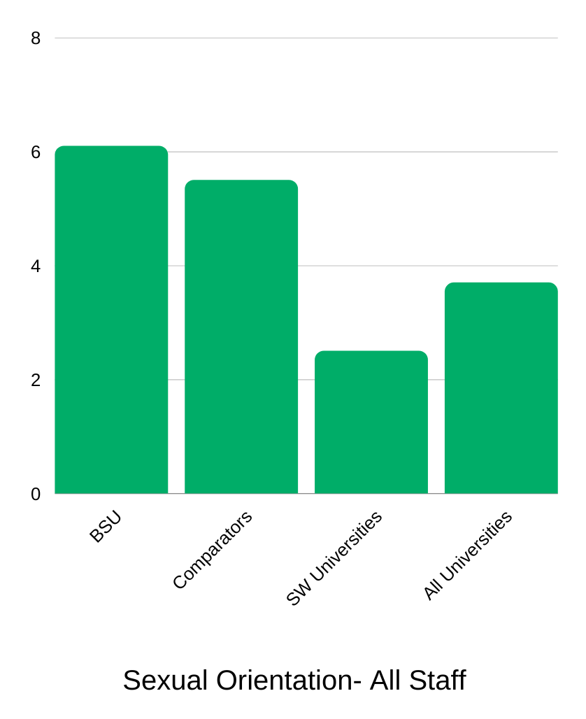
7.2 BSU’s non-disclosure rate is 20.6%. This means that the actual numbers of staff in the other categories may not be a true representation.

8.0 Staff Religion and Belief
8.1 The proportion of staff identifying as Christian is 23.6%. Those identifying as Other Religion Groups is 7.3%. The BSU comparator group is 23.2% and 7.1%, South West universities at 11.7% and 3.1%, and all Universities at 12.6% and 6.2% respectively.
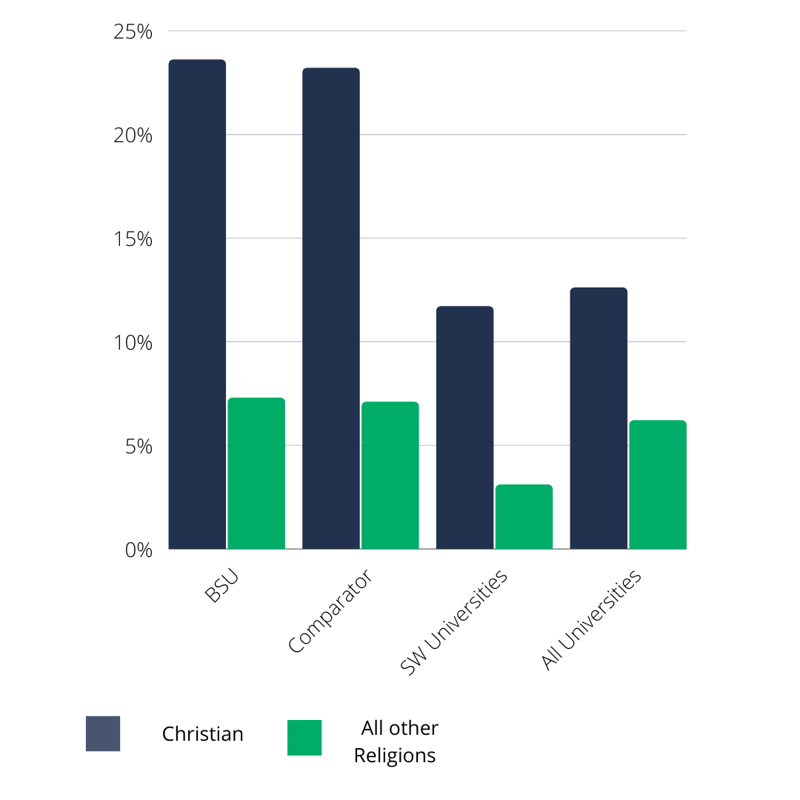

9.0 Staff Transgender Status
9.1 The proportion of staff in 2020/21 choosing to disclose that their gender identity did not match their assigned sex (referred to as the protected characteristic of ‘gender reassignment in the Equality Act 2010), was 0.4%. As a number of equality activities in the 2021/22 time period have focussed on trans inclusion, a rise in this figure in future years may indicate the success of these projects.

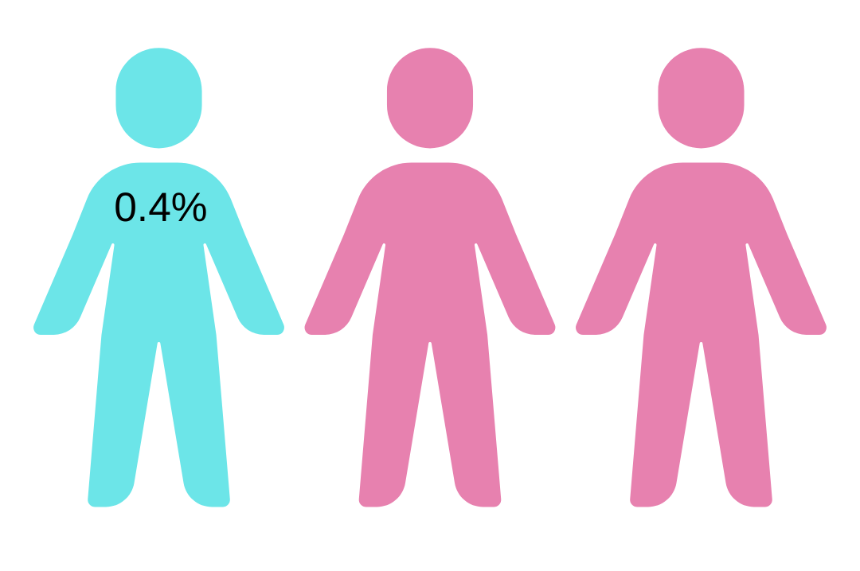
1:0 Student Data
1.1 Gender
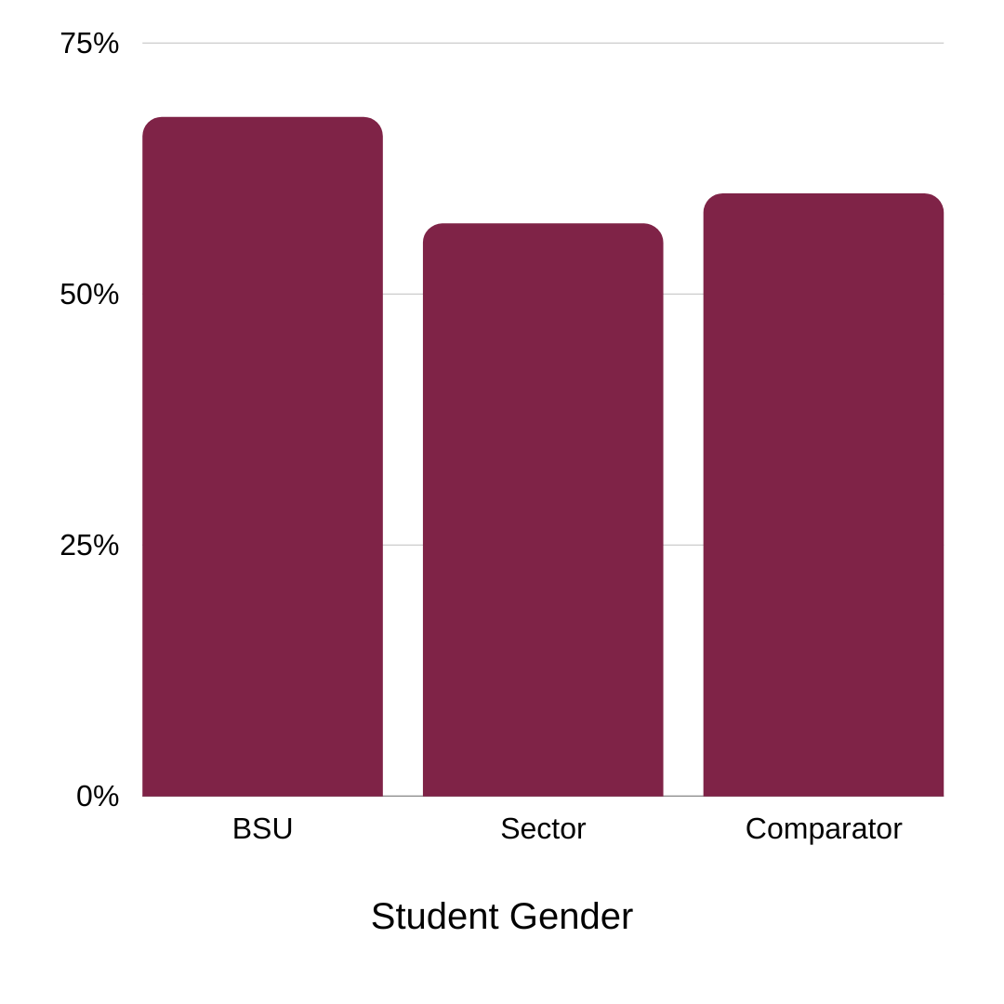
1.2 In 2020/21 67.6% of students identified as Female, 32.3% identified as Male, and less than 0.1% identified as ‘other’. 57% of students sector-wide identify as Female, and our comparator group is at 60.4%.

2.0 Disability
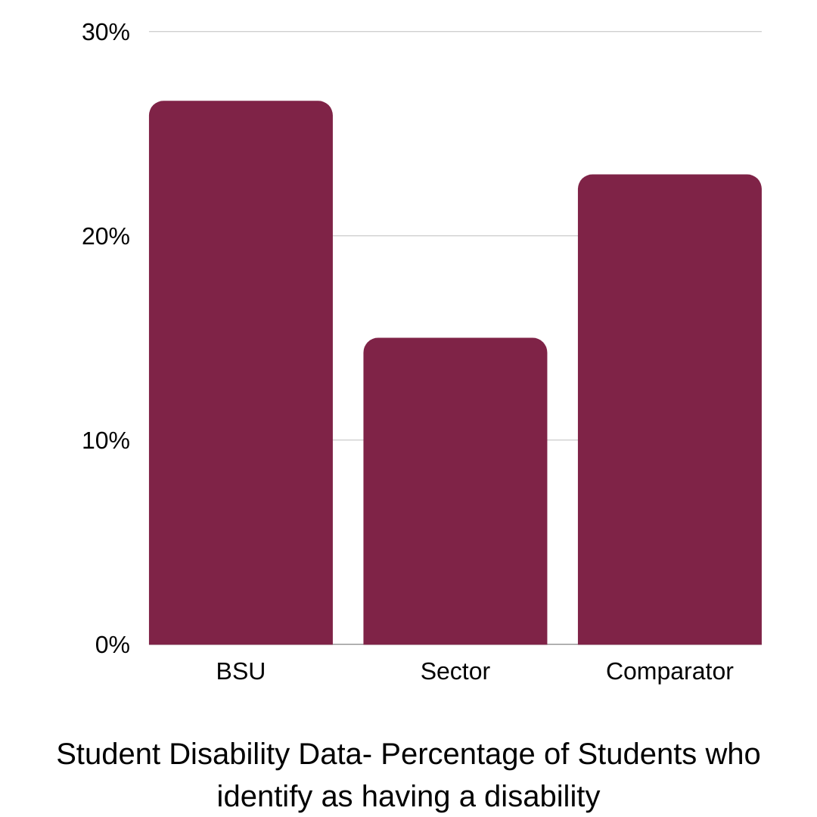
2.1 73.4% of our students said they had ‘No Known Disability. 26.6% of our students declared that they had one or more known disabilities. In our comparator group 23% of students declared having a disability. Sector-wide 15% of students identified as having a disability.

3.0 Sexual Orientation
3.1 76.5% of students identified as Heterosexual. 7.7% Bisexual, 1.4% Gay Woman/ Lesbian, 1.3% as a Gay Man, and 2.7% ‘other’. 10.1% refused to give this information.
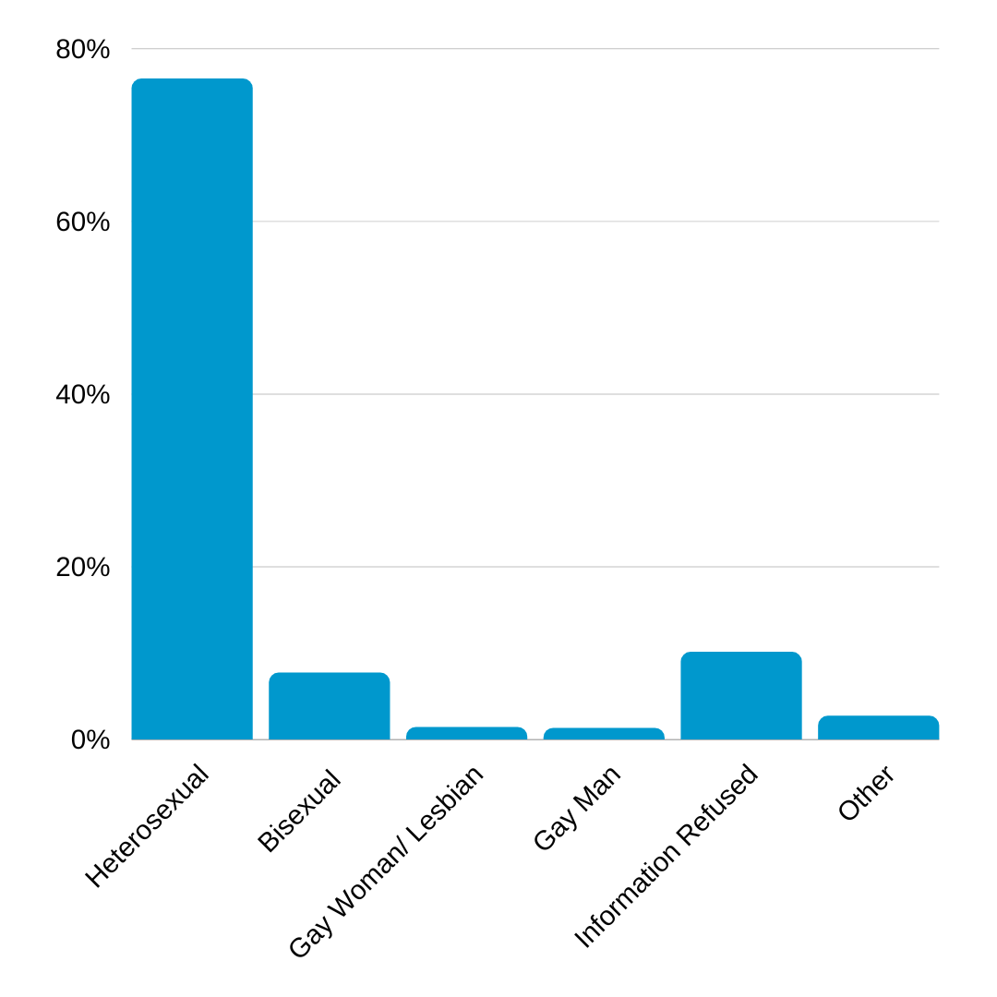

4.0 Religion
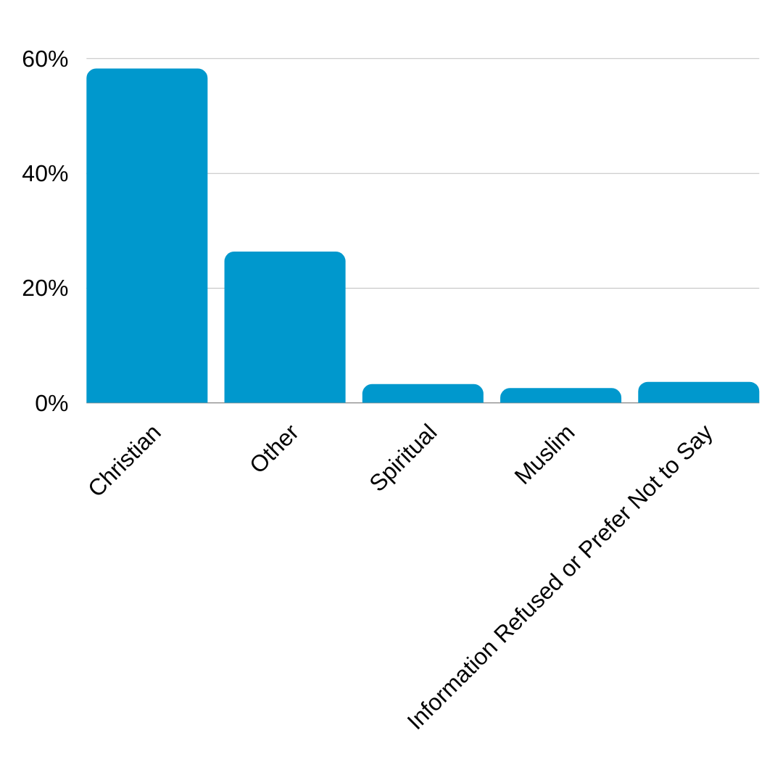
4.1 58.2% of BSU students identify as Christian, 26.3% identify with an ‘Other’ Relgion or Belief, 3.2% identify as Spiritual, 2.5% as Muslim, and 3.6% of the information was not given or they prefered not to say.

5.0 Ethnicity
5.1 85.6% of our students identify as White. 2.7% as Black, 5.6% Asian, 4.1% mixed Ethnicity, 1.6% other ethnicities and backgrounds, and 0.4% Not given/ Not Known.

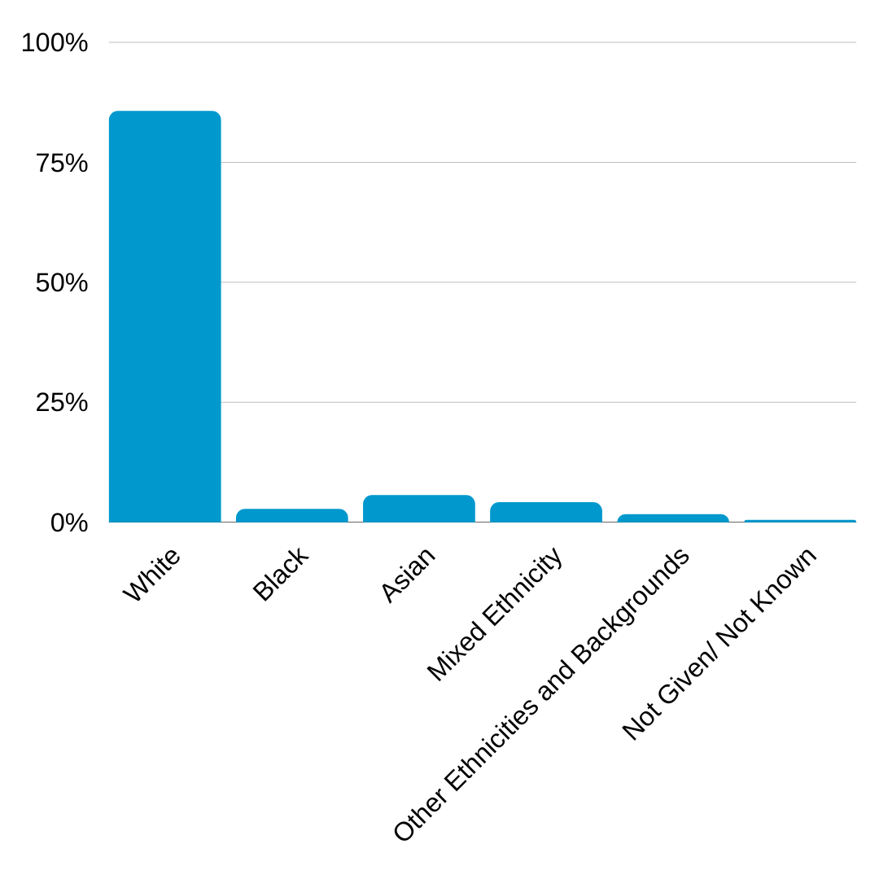
5.2 24% of the sector identified as BAME, we are however in line with our comparator group at 14.78% compared to 14% overall identified as BAME at BSU.

6.0 Student Domicile Data
6.1 Overall 6.91% of BSU students are international, our comparator group has 7.55% international students, and the sector has 21%, international students.

England: 71.09%
Wales: 6.75%
Scotland: 0.24%
Northern Ireland: 0.46%
Other UK: 0.54%
EU: 3.06%
Non EU: 3.85%
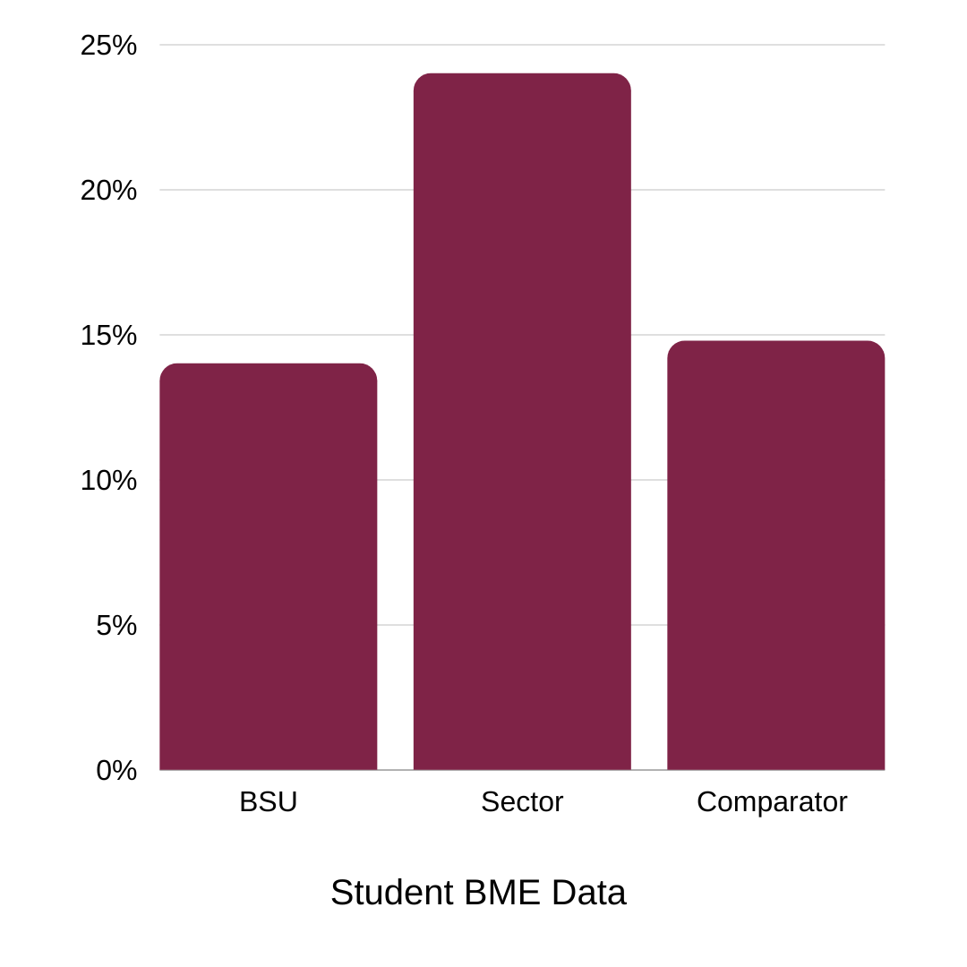
No Information: 12.93%

7.0 Student Transgender Status.
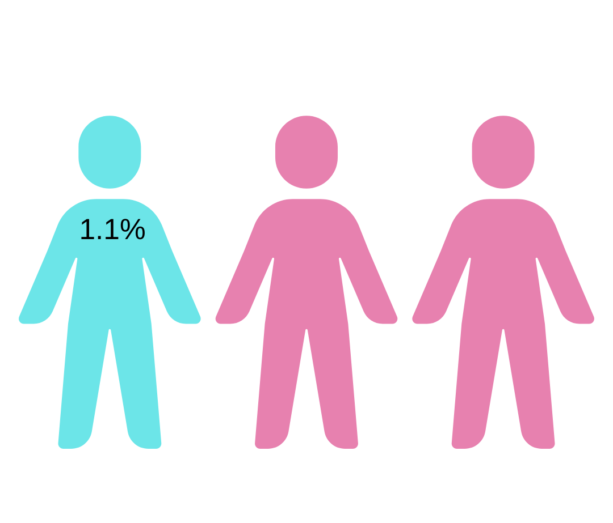
7.1 96.4% of students said that their gender identity matched their sex registered at birth. 1.1% said that their gender identity was different from their sex at birth and 2.5% refused to disclose this information.

8.0 Contacts
Human Resources: hrcontact@bathspa.ac.uk
Staff Equality information and events: sulis.bathspa.ac.uk/x/FQmc
Staff Networks (search on Sulis):

- Global Inclusivity Network (‘BAME’ staff)
- Disabled Staff Network and Disability Action Group
- Bath Spa+ (LGBT+ Staff)
- Women’s Staff Network
- Staff Equality Network
- Neurodivergent Staff Network

Staff Wellbeing: sulis.bathspa.ac.uk/display/HR/Health+and+wellbeing
Trade Unions: UNISON and UCU
Report & Support: reportandsupport.bathspa.ac.uk
Student Wellbeing Services: bathspa.ac.uk/students/student-wellbeing-services
Student’s Union advice: su-advice@bathspa.ac.uk
Student’s Union Networks, reps, and campaigns: bathspasu.co.uk/voice

