

Short Course Unit Inclusion Guidance
2026-2027

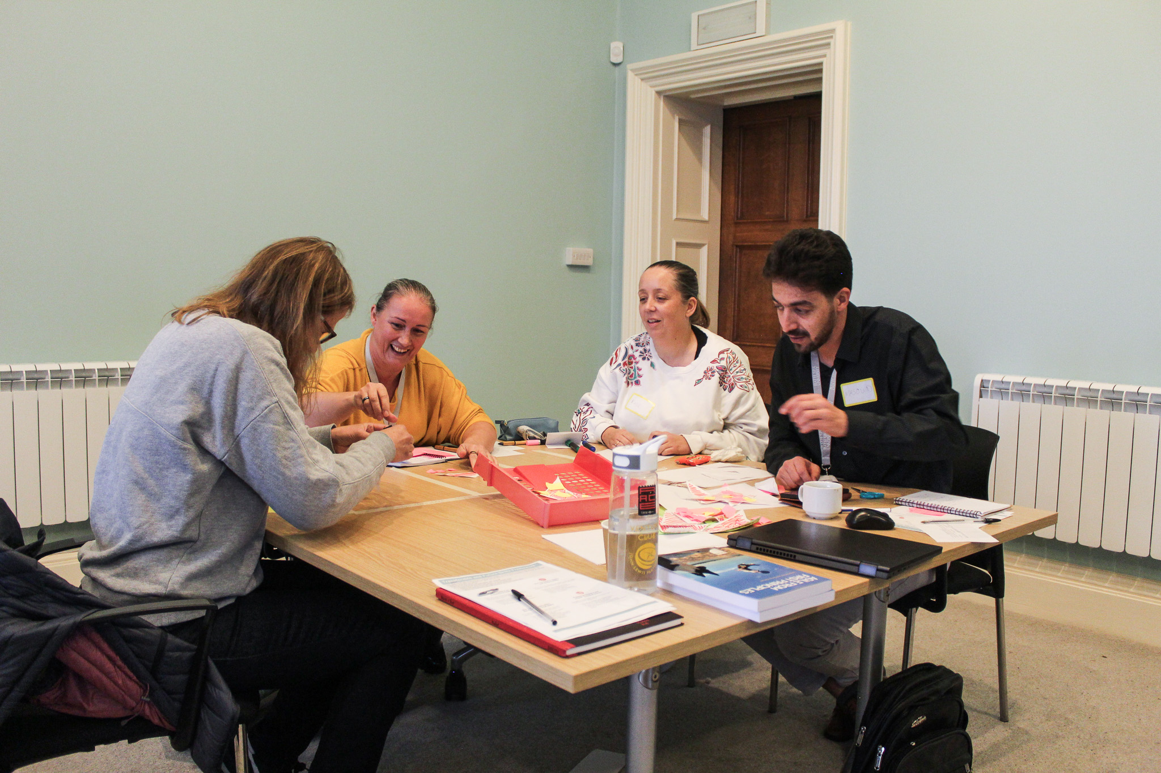

1.Purpose and Vision
We believe that every learner should be able to access professionally creative education that promotes growth academically, personally, and socially, building confidence and resilience along the way.

2. Who This Guidance Supports
We work with adult learners aged 18+ from a wide range of backgrounds, ensuring our programmes are accessible and inclusive. Our learners may include those who:
- Are long-term unemployed or economically inactive
- Whose first language is not English
- Are from the Global Majority
- Experience poor mental health, disability, neurodivergence, or have diagnosed or undiagnosed Special Educational Needs (SEN).
- Have caring responsibilities
- Have had negative experiences of education in the past
- Lack confidence, trust, or the basic skills needed to re-enter learning
- Are transitioning from the military or are spouses/partners of those actively serving

3. How Inclusion is Embedded in Our Provision
Inclusion begins at the earliest point of engagement, as part of Information, Advice and Guidance best practice and continues throughout the learner journey.

Recruitment
We promote inclusive recruitment by using accessible and inclusive marketing, clear information and outreach activities that encourage participation from learners of all backgrounds, abilities and experiences. We aim to reduce barriers to entry by offering information, advice and guidance and early opportunities to share support needs.

Admissions
Our admissions processes are designed to be fair, transparent and supportive, ensuring that learners feel welcomed and able to disclose any additional needs. Initial conversations help us understand individual strengths, goals and required adjustments from the outset. Learners are clearly guided through each stage of the admissions and support process, including how to disclose support needs, what support is available, and what to expect throughout their journey. This ensures transparency and builds confidence from the outset.

Curriculum
Inclusive practice is embedded within curriculum design and delivery through flexible teaching approaches, differentiated learning activities, and a supportive learning environment. We provide appropriate reasonable adjustments and targeted support to enable all learners to participate, progress, and achieve. We meet our duty under the Equality Act 2010 to make reasonable adjustments, ensuring learners with disabilities or health conditions are not placed at a disadvantage. BSU Equality Policy
Accessibility is considered across all aspects of provision, including learning environments, digital platforms, and communication methods, to ensure all learners can fully engage. Where courses contain final examinations by accredited bodies, reasonable adjustments are supported in line with the guidelines set by the awarding organisation. All delivery staff are responsible for embedding inclusive practice and implementing agreed support strategies, including those outlined in learner profiles and access plans.
This guidance should be read alongside the Accessible Teaching and Learning Guidance, approved by the Education Committee, which outlines our baseline approach to inclusive teaching and learning. The guidance embeds the majority of reasonable adjustments as part of standard teaching practice.
Inclusive Teaching – Bath Spa University

Post-Provision
Inclusion continues beyond programme completion through progression support, careers guidance, and signposting to further education, training, or employment opportunities. We maintain contact with learners where appropriate to track outcomes, gather feedback, and understand the longer-term impact of our provision.

3.1 Our Inclusive Support Framework
Learners are actively involved in identifying their support needs and shaping their access plans, ensuring support is person-centred and reflective of their individual goals and preferences. Information relating to learner support needs is handled sensitively and shared only with relevant staff to ensure appropriate support, in line with data protection requirements and in compliance with the GDPR regulations.

Highlighted in Interview / Highlighted in 1–1
Learners may choose to share their support needs at different stages. This could be during the interview, early in one-to-one discussions, or later at the start of the course once trust has developed or the need becomes relevant, for example when preparing for assessment or exams.

Learner Profiles for All
A learner profile is created for every learner to capture key information such as strengths, goals, learning preferences and any support requirements, helping staff deliver inclusive and personalised teaching. Learner profiles are re-visited at key points during provision to ensure learners feel fully supported.

RAG Rated (Internal Use Only)
Learners’ support needs are internally reviewed and categorised using a RAG rating system to help prioritise support, monitor risk and inform planning across the provision.

Provision Map
A provision map for staff outlines the range of support strategies, interventions and resources available to meet identified needs.

SEND Register
Where appropriate, learners are recorded on the SEND register and accessibility needs are reviewed to ensure reasonable adjustments and inclusive learning environments are in place.

Access Plan
An individual access plan is developed where required, detailing agreed adjustments, support strategies and responsibilities to enable the learner to fully participate and achieve. The plan will also be used to deescalate or change adjustments where needed. Access plans will be regularly reviewed with the learner.

Inclusive Support Documentation
- Procedure Flow chart
- RAG rating guidance
- Emergency Access Plan
- SEND register
- Provision map
- Learner profile template
- Access plan template

Quality Assurance of Inclusion
We ensure inclusion is effective through:
- Clear Quality Improvement actions
- Weekly tracking of attendance and assignment progress
- Teaching observations
- Learner voice and feedback
- Access plan reviews
- Regular review of support strategies and their impact, using data, feedback, and outcomes to ensure high-quality provision and continuous improvement for all learners
- Papers submitted to Quality Management Committee

Our commitment
- We are committed to creating an inclusive learning environment where every individual feels safe, respected, and able to succeed.
- We will understand each learner as an individual, including their background, experiences, goals, and support needs, so we can adapt communication, delivery, and support effectively.
- We will build trust and create safe spaces for open conversations, enabling learners to share challenges, aspirations, and lived experiences to improve engagement and outcomes.
- We will maintain ongoing connections with learners through follow-ups and outcome-focused conversations, supporting reflection, access to further support, and a deeper understanding of the full learner journey.
- We will take a proactive and inclusive approach that values diverse perspectives and recognises wider influences such as socio-economic factors, structural barriers, and personal preferences.
- We are committed to removing barriers to learning and ensuring fair and equal access to opportunities for all learners.
- We will commit to continuous development as a team, recognising that both learners and staff are at different stages and that honest reflection and ongoing learning are essential.
- We will embed reflective practice across our provision, acknowledging where improvements are needed, reviewing our impact, and adapting our approach.
- We will measure, review, and report on progress, using clear actions and review points to ensure accountability and drive meaningful, sustained improvement.

Safeguarding and Wellbeing
We recognise that effective learning can only take place when learners feel safe, supported, and emotionally well. Safeguarding and wellbeing are central to our inclusive approach.
We are committed to:
- Promoting a safe and supportive learning environment for all learners
- Identifying and responding to safeguarding concerns in line with BSU policy
BSU Safeguarding Policy
- Supporting learners with their emotional wellbeing and mental health
- Signposting learners to appropriate internal and external support services
- Ensuring all staff understand their safeguarding responsibilities and receive appropriate training Where concerns are identified, these will be managed sensitively and in line with safeguarding policies, ensuring learners are supported appropriately throughout.

Review and Monitoring
This Guidance is reviewed annually, or sooner if required, to ensure it remains effective and aligned with current legislation and best practice.
Its impact is monitored through learner outcomes, feedback, quality assurance processes, and progression data.

