Getting to The Mount Without
This document contains information about how to get to the exhibition venue. At the end of the document there are guides with instructions and pictures on how to find the exhibition from each entrance and nearby car parks.
If you have any questions about getting there, please email:
wearethepeople@bathspa.ac.uk

Venue Address
The Mount Without, Upper Church Lane, St. Michael’s Hill,
Bristol BS2 8FN.

How do I find the venue?
The Mount Without is an old church close to the bottom of St. Michaels Hill. You can enter the venue grounds from St. Michaels Hill, Old Park Hill, and Lower Church Lane. The route from Lower Church Lane includes steps. The route from St. Michaels Hill includes a steep ramp. (See guides at end of document for more details). The exhibition is in the main church building.
Picture of The Mount Without from St Michaels Hill.
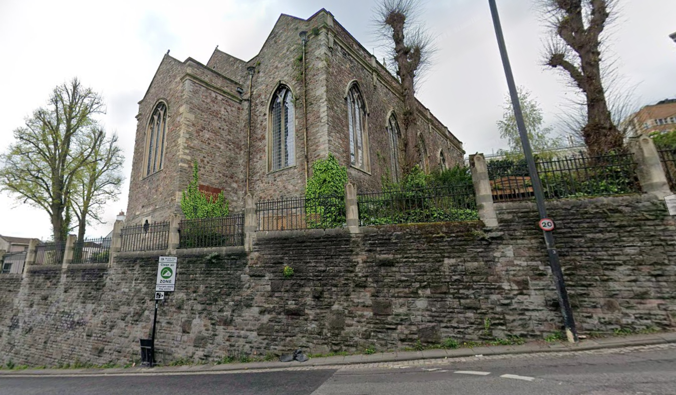

Street map with each entrance marked.
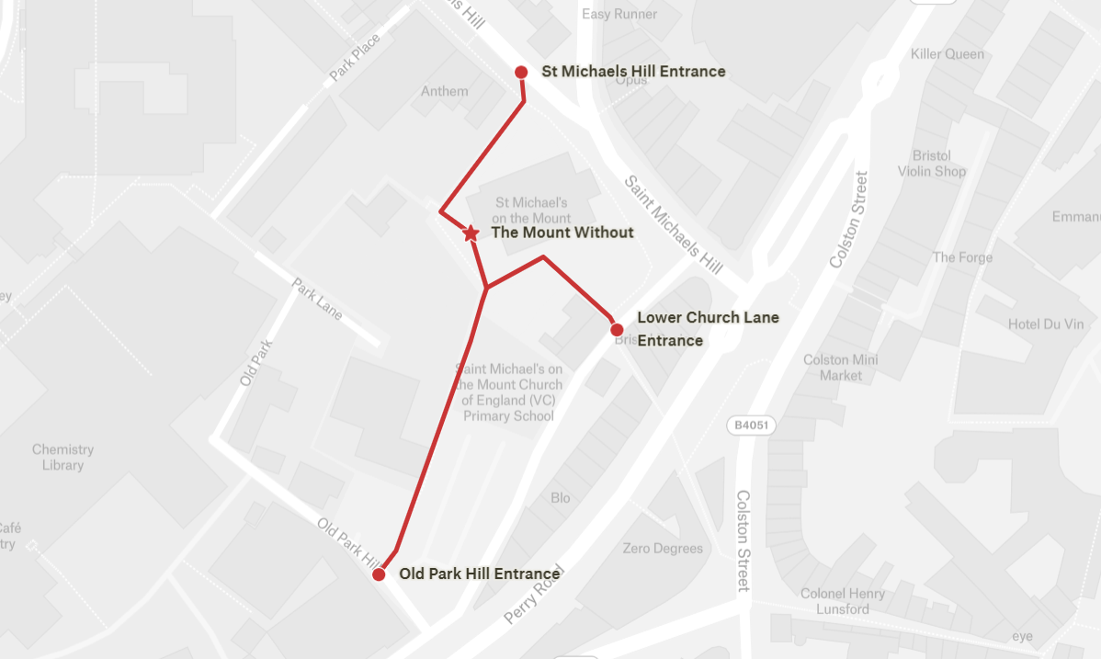

Transport options

By bus
There are limited public transport options close to the venue. To plan your journey by bus you can use First Bus journey planner. Many local buses stop in The Centre. From here the venue is approximately 15 minutes’ walk away (0.3 miles) up a steep hill or steps.

By bike
Bikes can be locked on the railings around the main church.
E-scooters and e-bikes are available for hire in Bristol. For more information go to Travel West scoot and bike hire.

By train
Clifton Down is the closest train station. Bristol Temple Meads is the main train station in Bristol. To plan your journey by train you can use National Rail journey planner.

By taxi
Taxis can drop off on Old Park Hill or St Michaels Hill. You can find details of licensed accessible taxis on the Bristol City Council website.

By car
There are guides at the end of the document which provide instructions and pictures showing how to get to the venue from each car park.

Trenchard Street long stay car park
Trenchard Street long stay car park is about five to ten minutes’ walk away from the level 8 exit on Park Row/ Perry Road. The route to the venue is uphill and has uneven ground. There are disabled parking bays on level 1 and level 8. You can find pricing and address on the Bristol City Council website.

Old Park Hill University of Bristol car park
Old Park Hill University of Bristol car park is about three minutes’ walk away. Parking here is only permitted after 16:00 on weekdays, and anytime on Sunday. Parking in the permitted times is free. The route to the venue has uneven ground.

St Michaels Hill on street parking
St Michaels Hill on street parking is about three minutes’ walk away. The route to the venue is on a steep hill, includes a steep ramp and has uneven ground. Parking is free and without time restriction with a valid Blue Badge displayed. You can find pricing and time restrictions on the Bristol City Council website. You can pay for parking using the app RingGo (location code 2798).

Getting to venue - instructions and pictures

From Trenchard Street car park
and Old Park Hill (start at step 5):
- Exit the car park on level 8 on Park Row. Turn right and head towards the traffic lights.
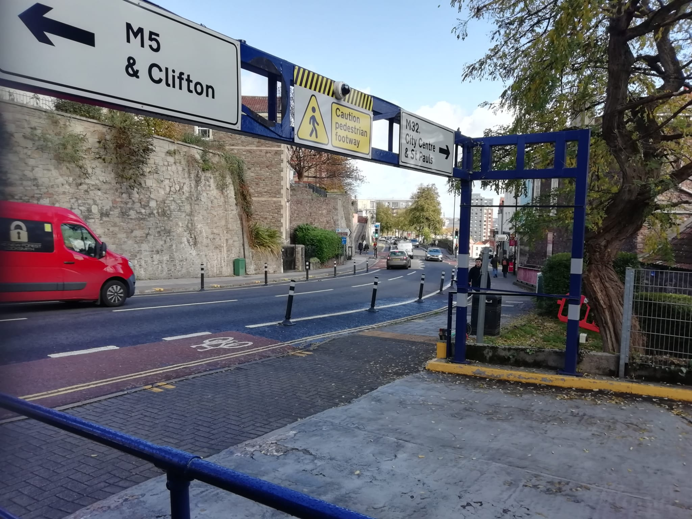
- Cross over at the traffic lights and turn right towards Old Park Hill.
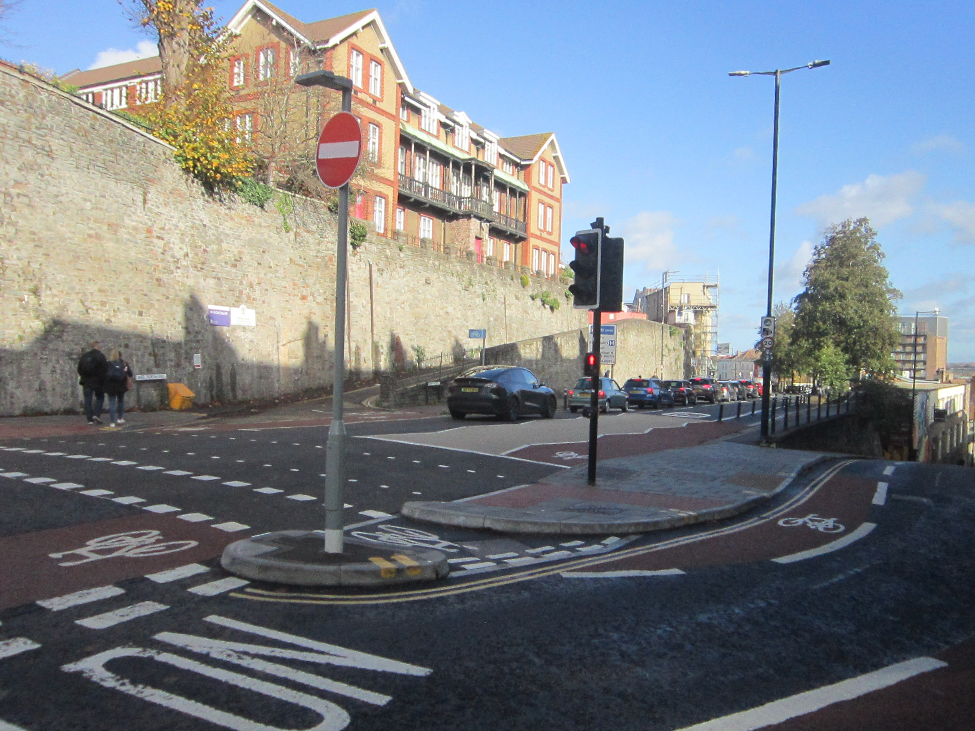
- Head left up Old Park Hill. The pavement here is narrow and steep.
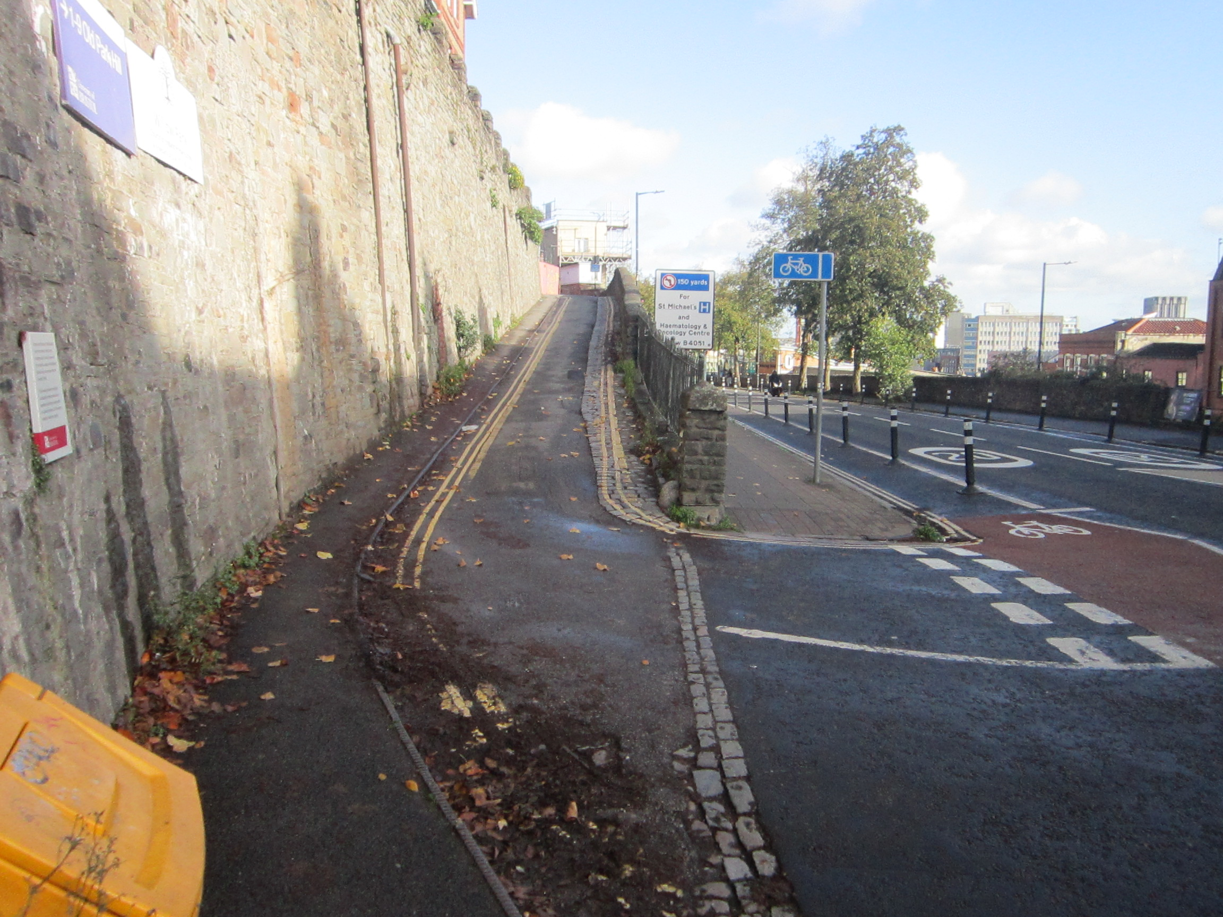
- Follow the road round to the left towards the entrance of the car park.
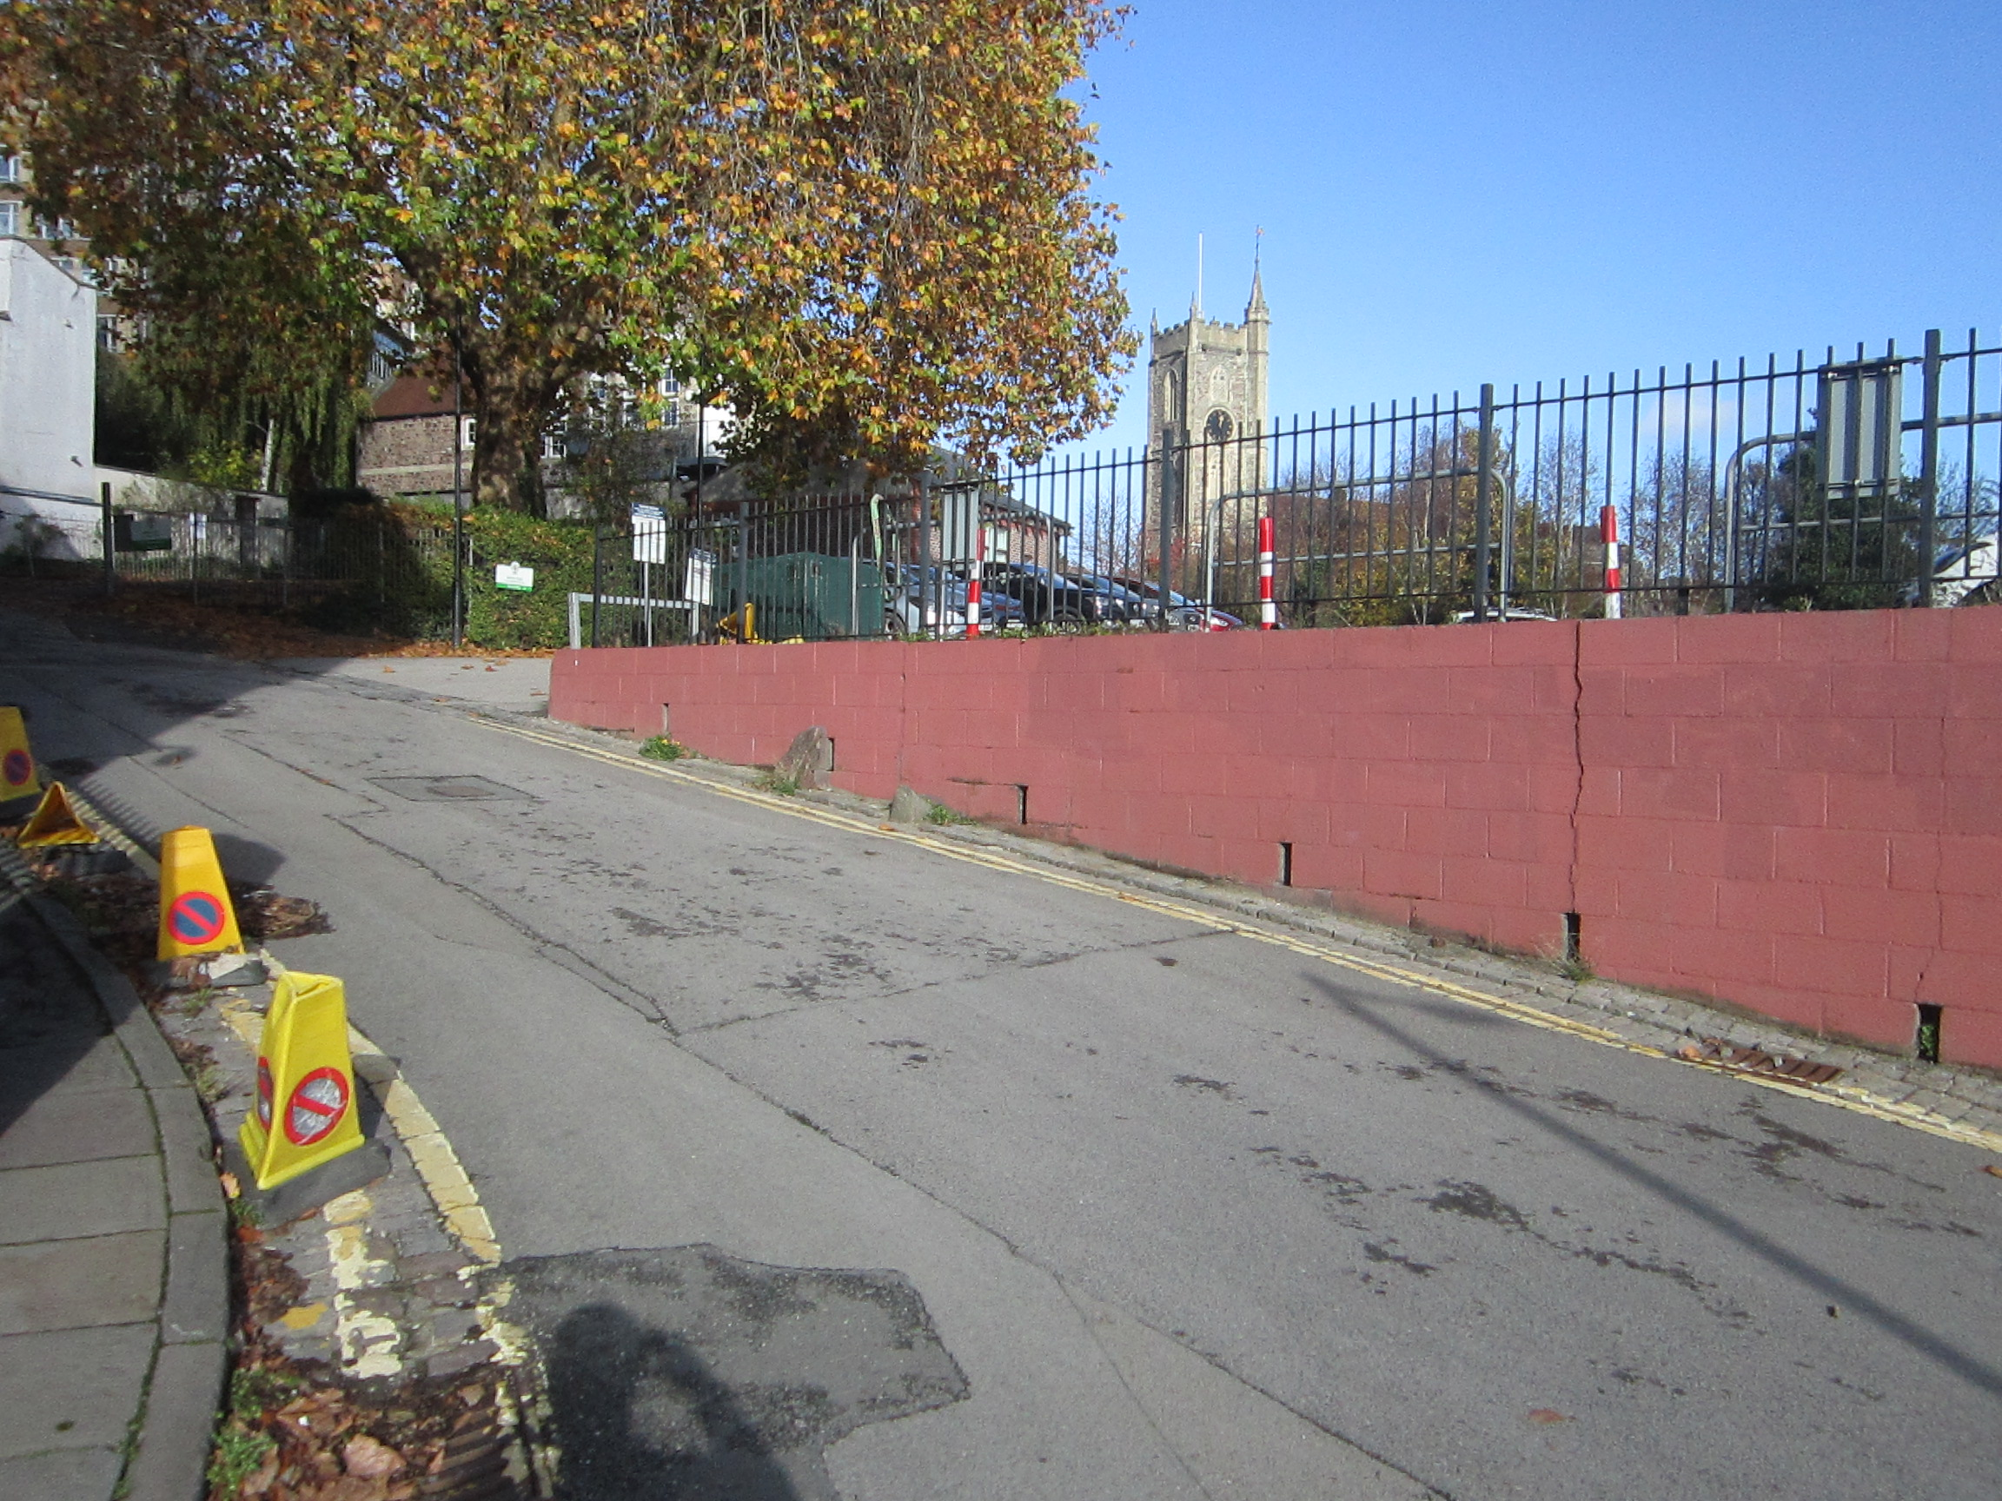
- Head down the alleyway to the left of the car park. The entrance to the alleyway is often covered in leaves which may be covering the step down from the pavement. This area may be slippy. Some parts of the alleyway are bumpy and have uneven ground. 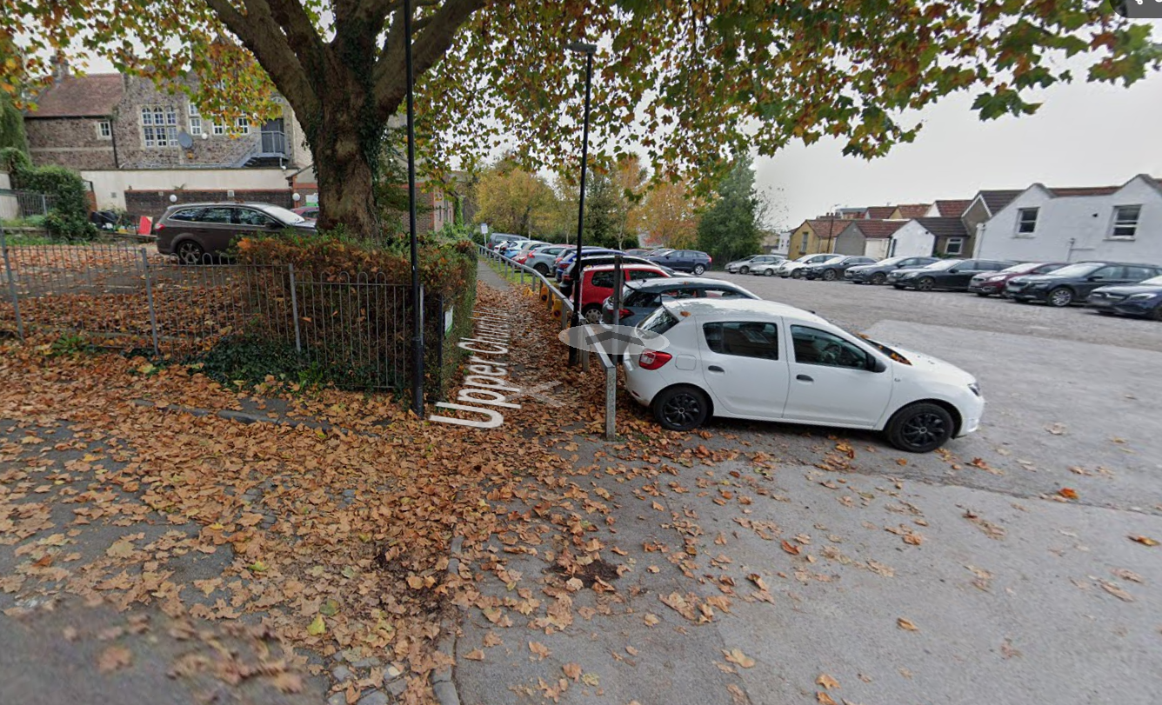
- Continue down the alleyway, you will pass a school on your left. 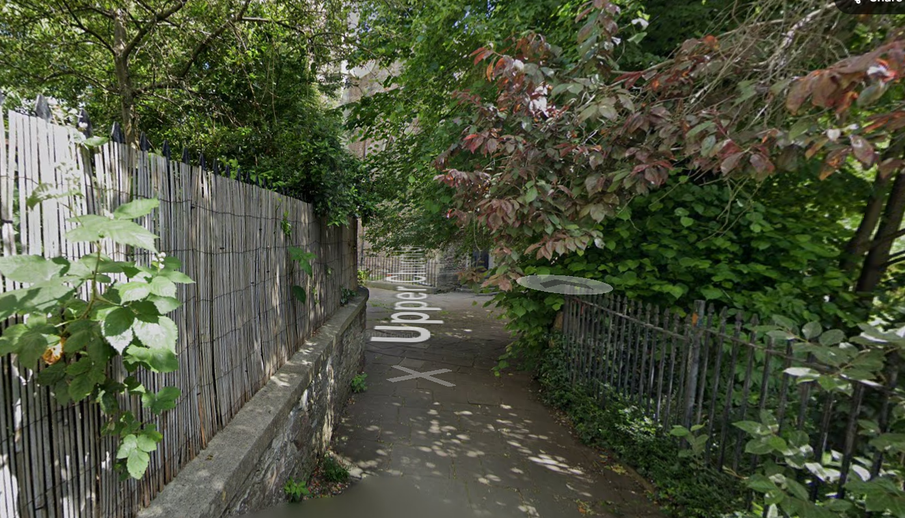
- At the exit of the alleyway go round to the left of the church. The paving stones are uneven and bumpy in places. 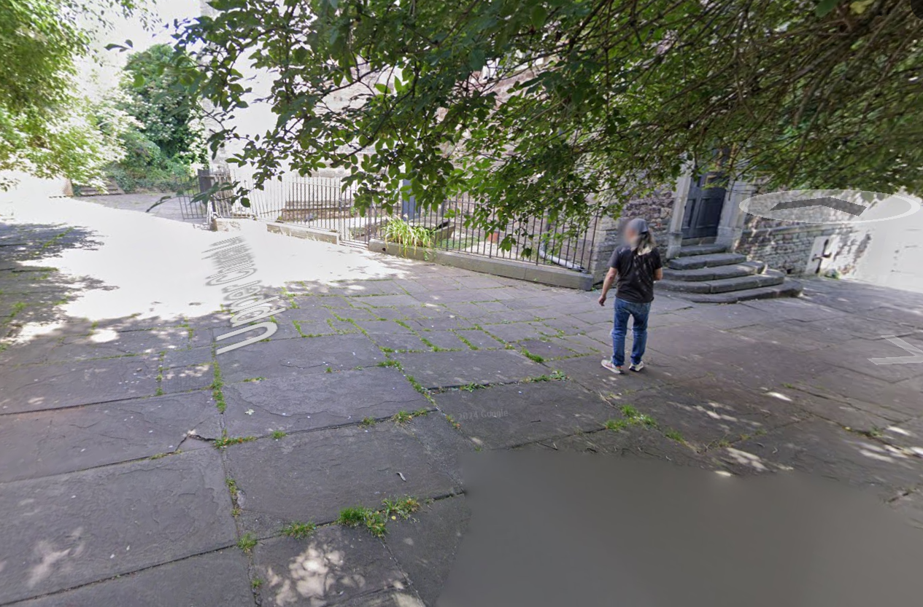
- Enter the main church through the gate and double doors. 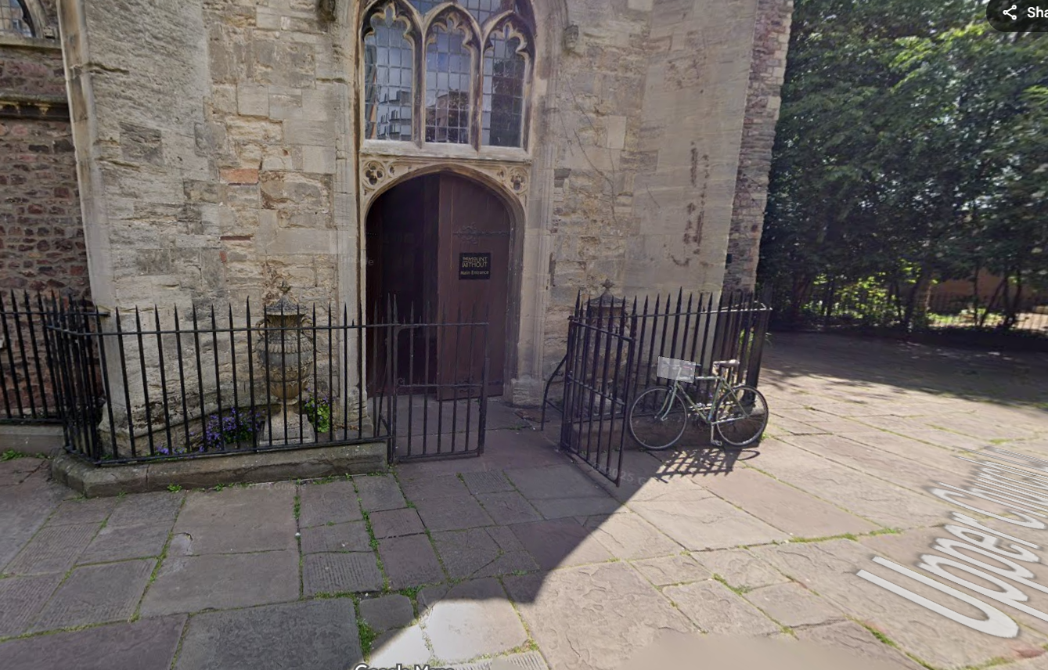

From St Michaels Hill:
- Head down St Michaels Hill towards the city centre. On the upper pavement on the right-hand side of the road there are frequent sets of steps. 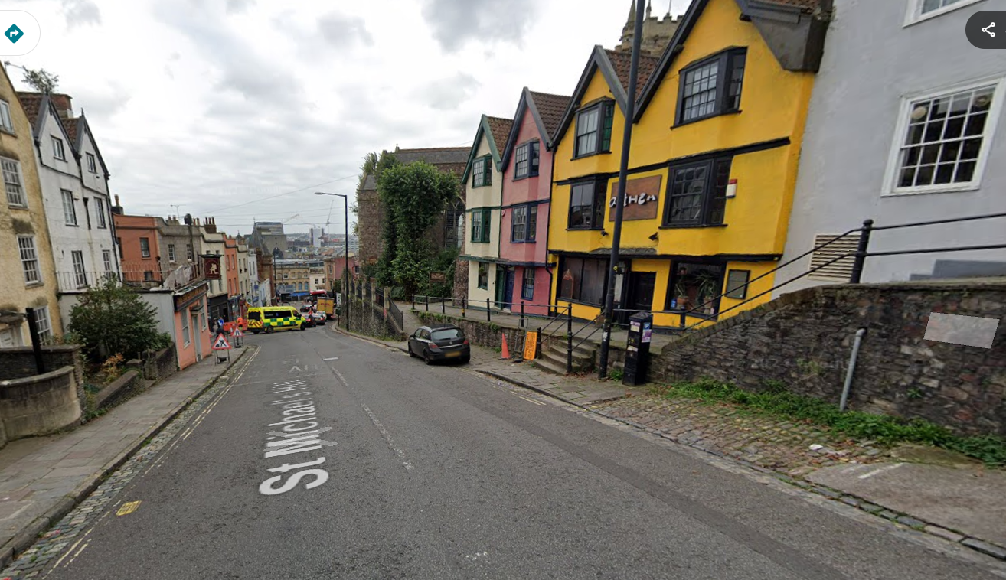
- There is a steep ramp going up from the roadside to the church grounds. 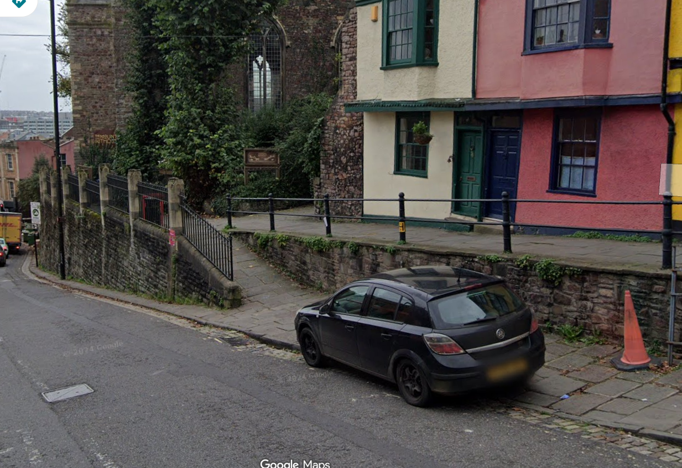
- Head round to the right-hand side of the main church. The paving stones are uneven. 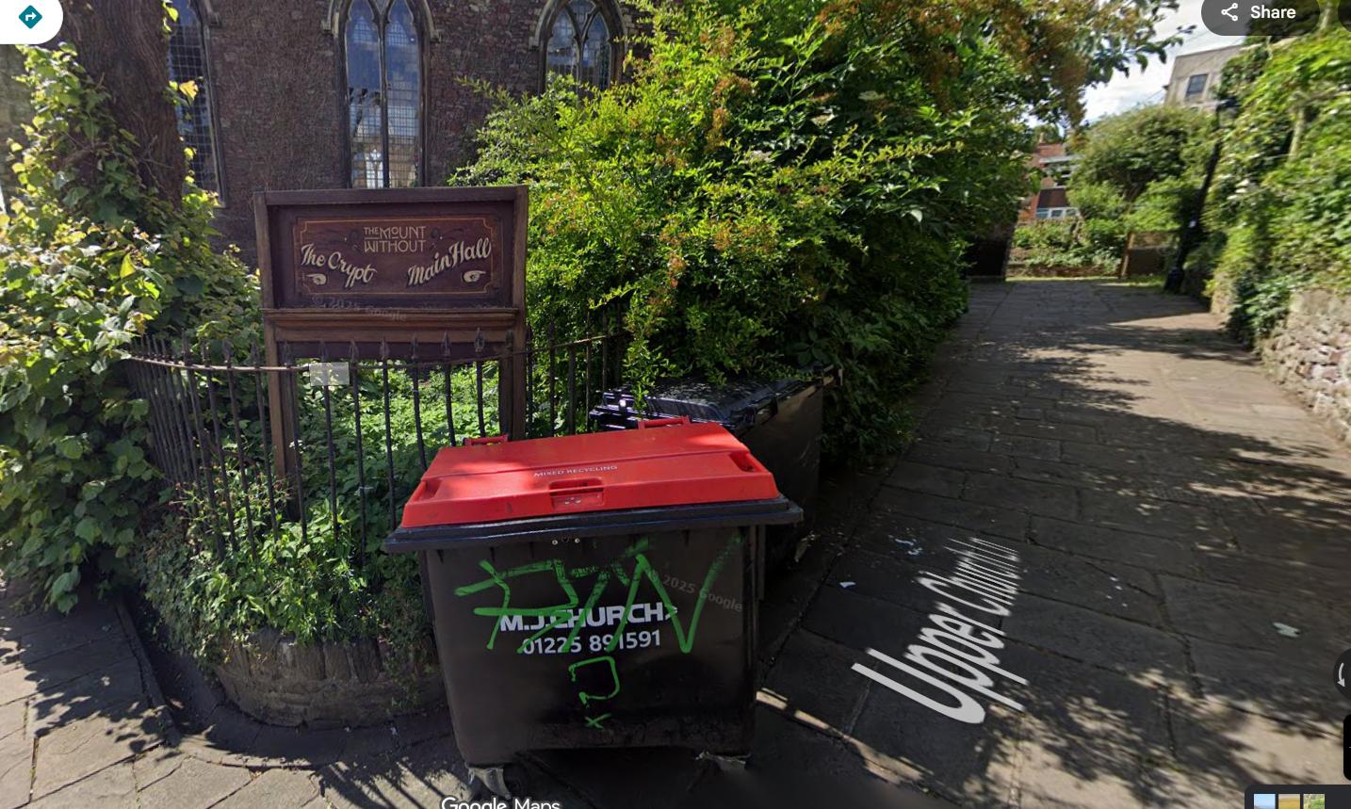
- Enter the main church through the gate and double doors.

From Lower Church Lane:
- Take the steps up on the left-hand side. The steps are uneven and may be slippy. The steps don’t have railings.
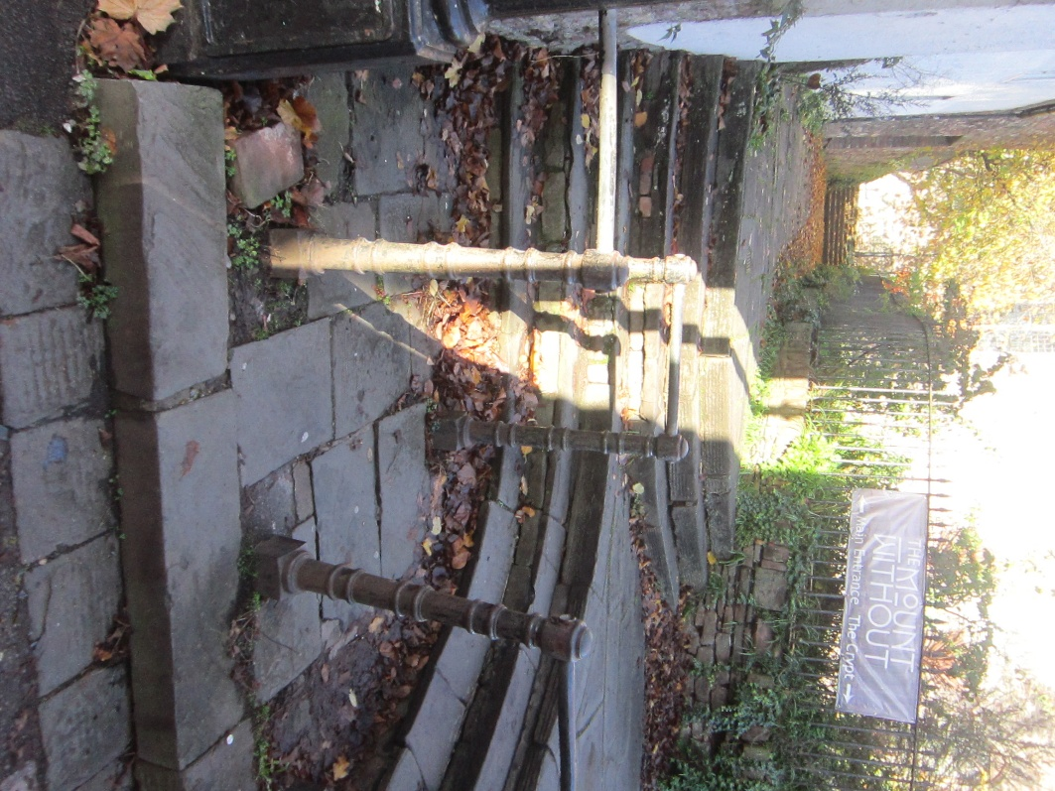
- Head up the path towards the church and up the steps.
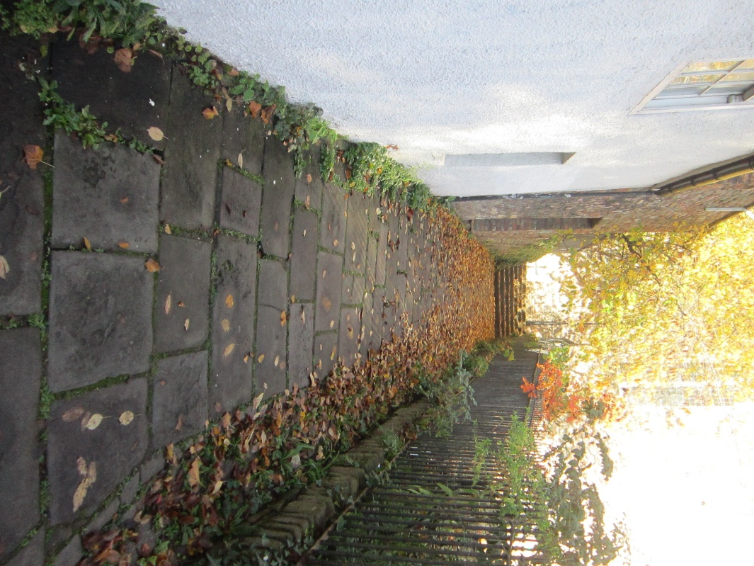
- Follow the path round to the left of the venue.
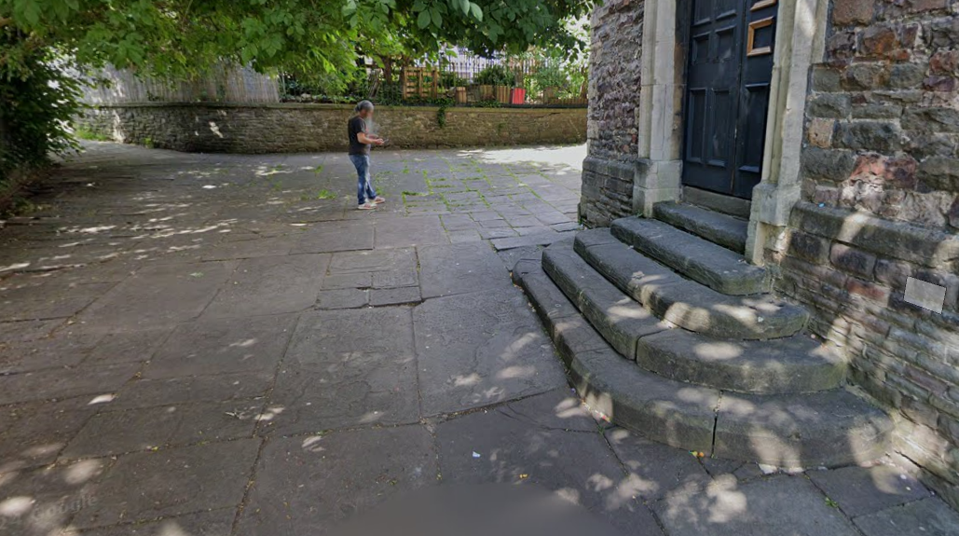
- Enter the main church through the gate and double doors.

