Venue and Exhibition Access Information
This document contains information about getting around the venue and experiencing the exhibition. At the end of the document there are pictures and descriptions of the venue.
If you have any questions about the venue facilities and experiencing the exhibition, please email:
wearethepeople@bathspa.ac.uk
When the exhibition is open, we will have staff there to welcome you. Please let us know if there is anything we can do to support you in accessing the space and experiencing the exhibition.

Assistance dogs
You are welcome to bring your assistance dog into the venue.
There is outside space around the main church.

Accessible toilet
There is an accessible toilet in the exhibition space. It is roughly 1.8m by 1.5m. See pictures below.
Pictures of the accessible toilet with grab bars.
.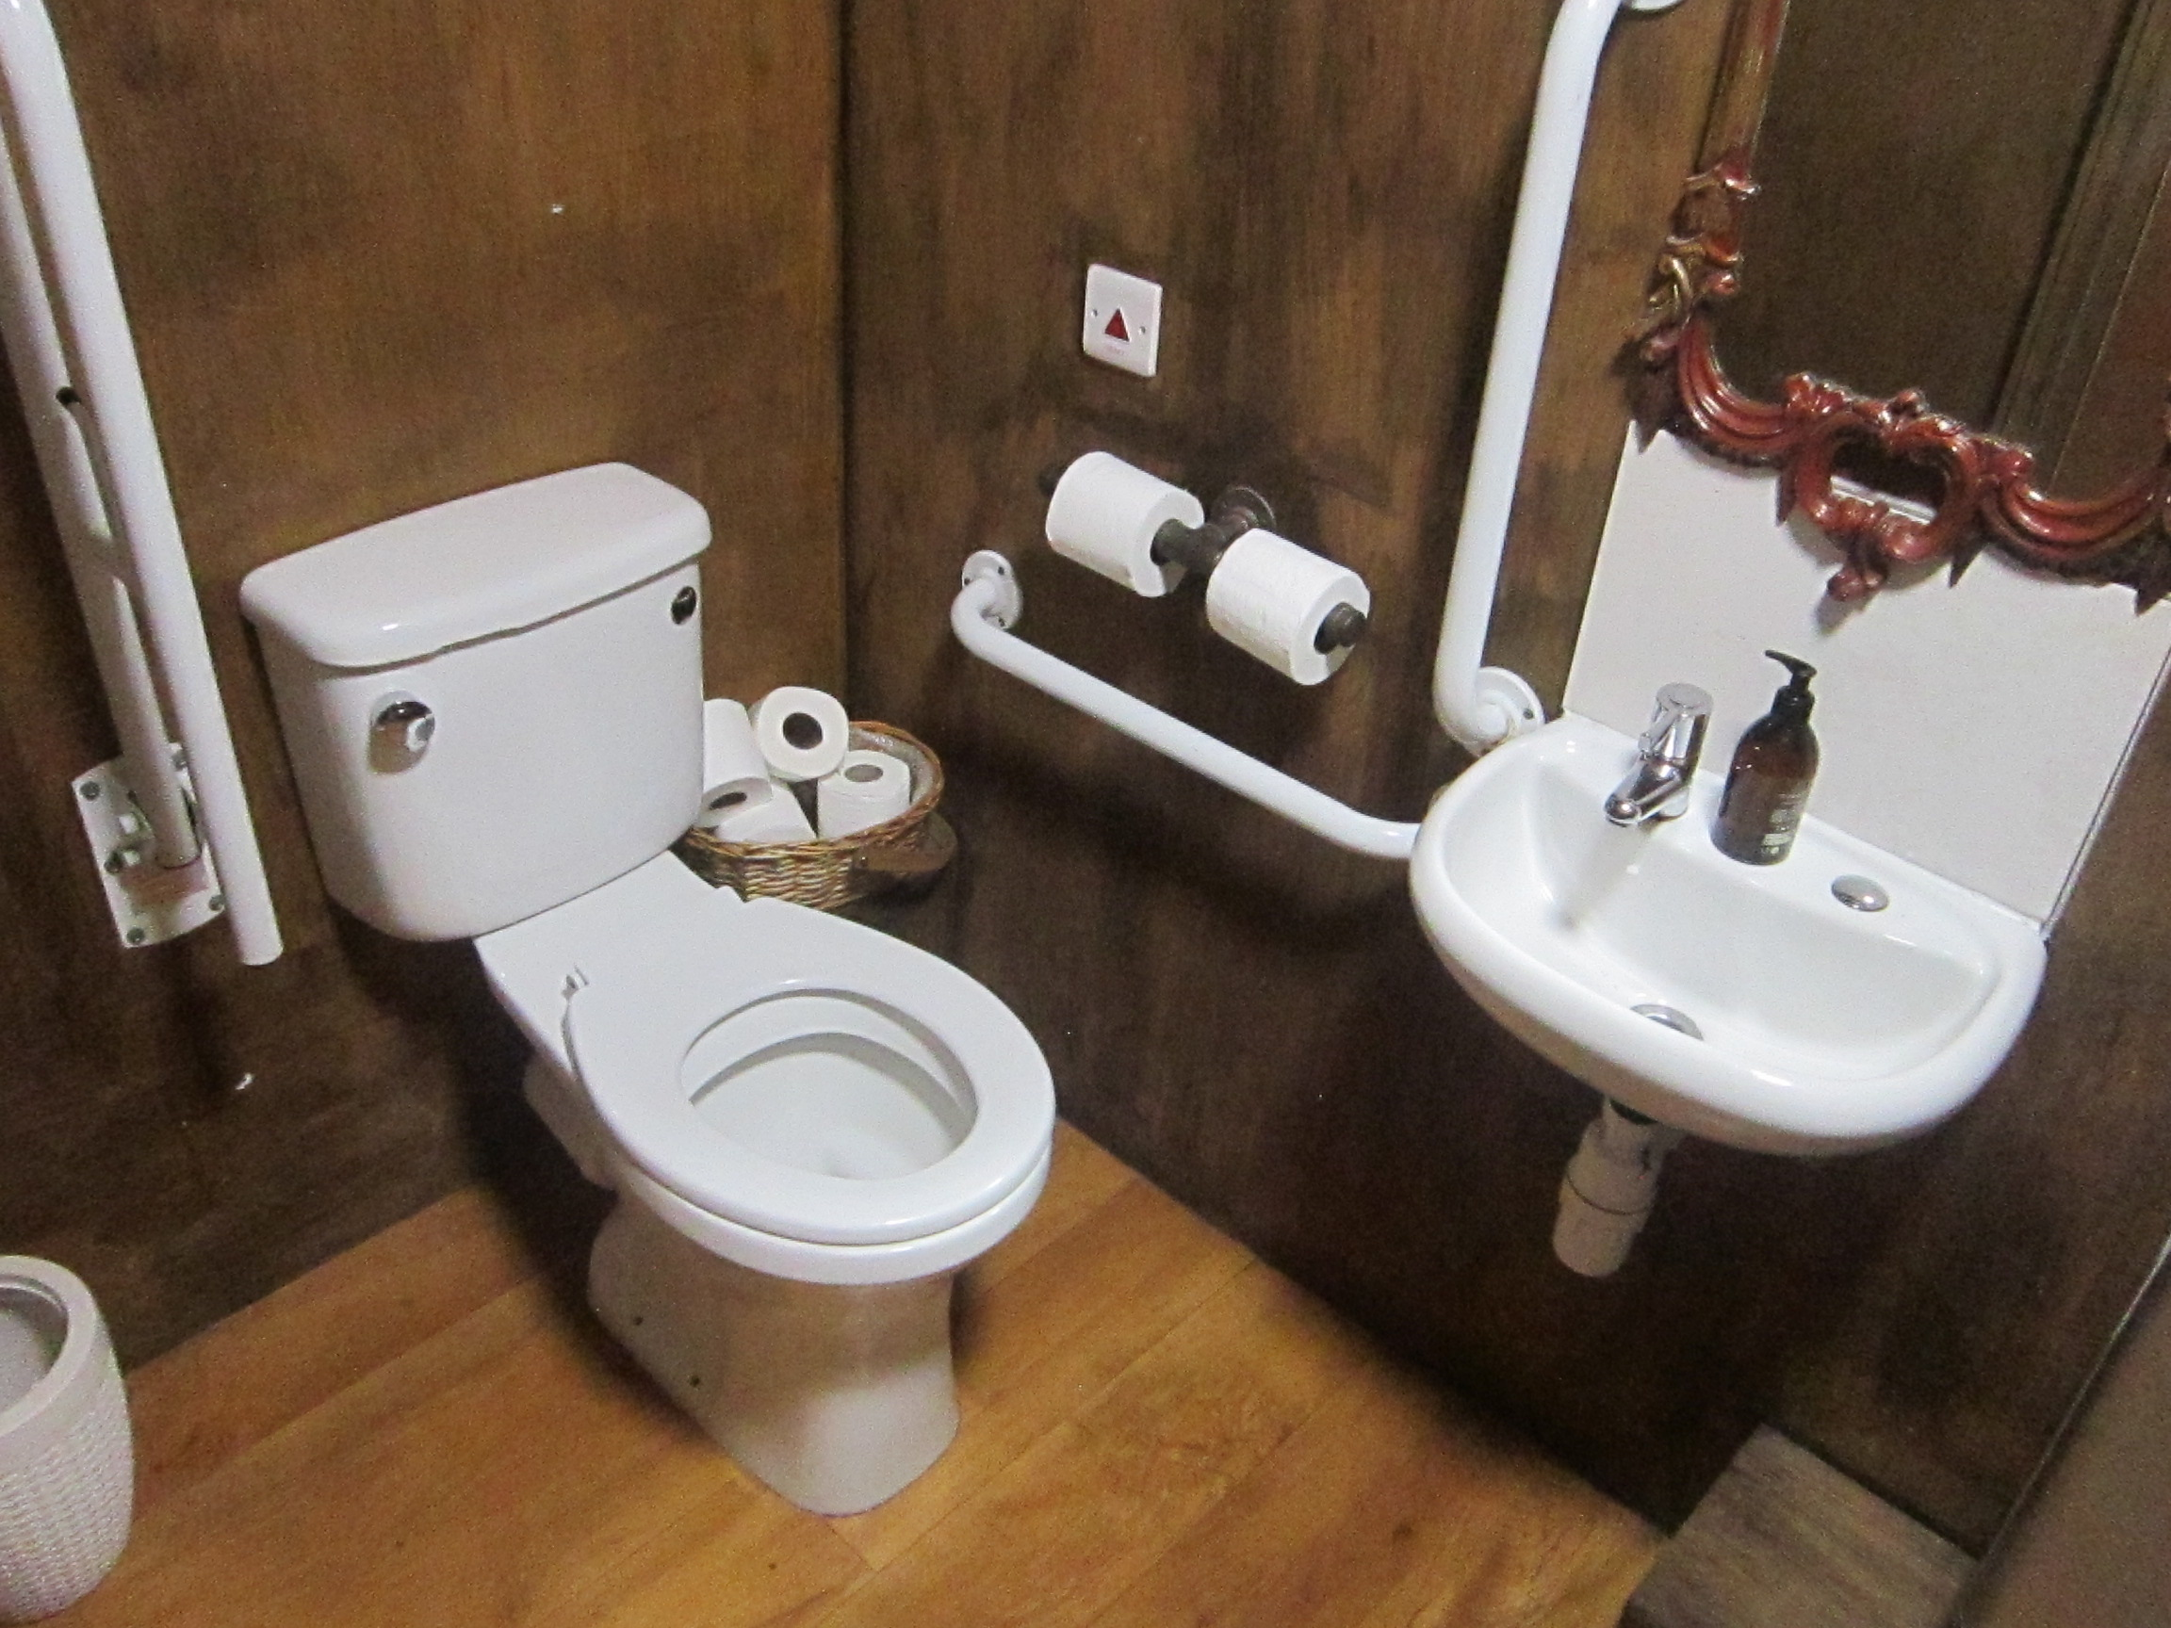
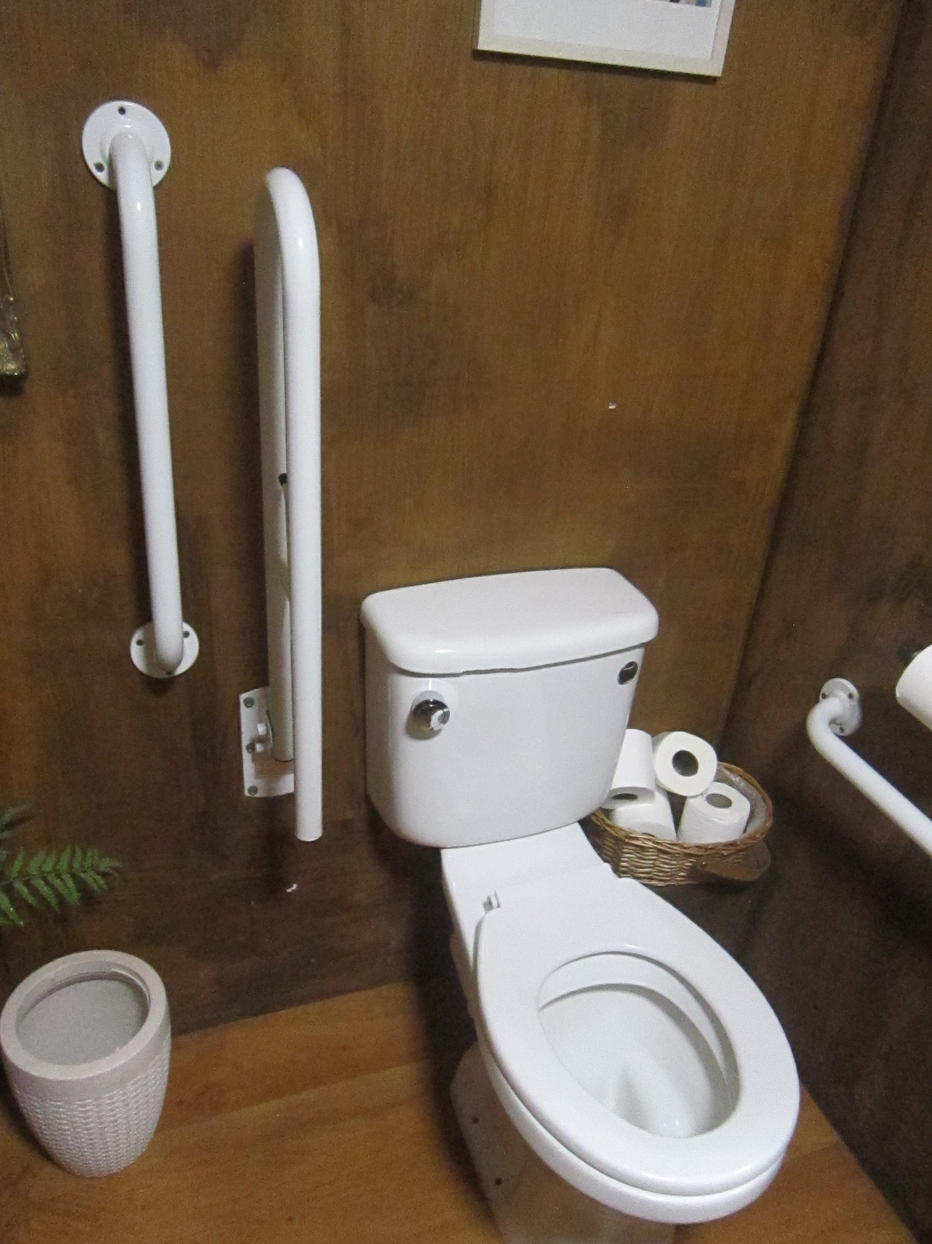
Pictures of the door of the accessible toilet, and the hand-dryer.
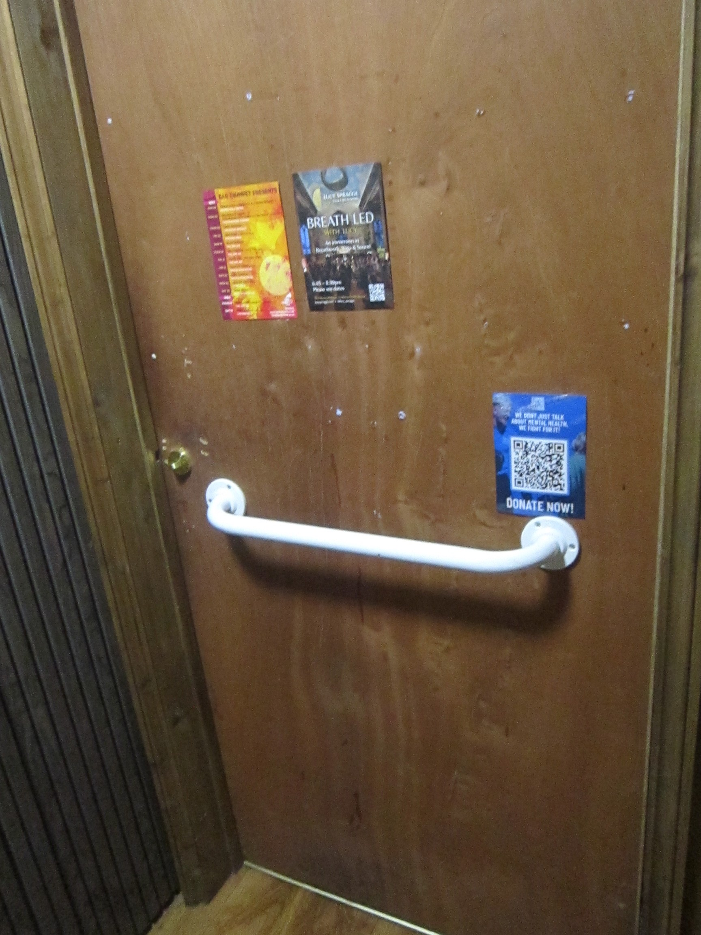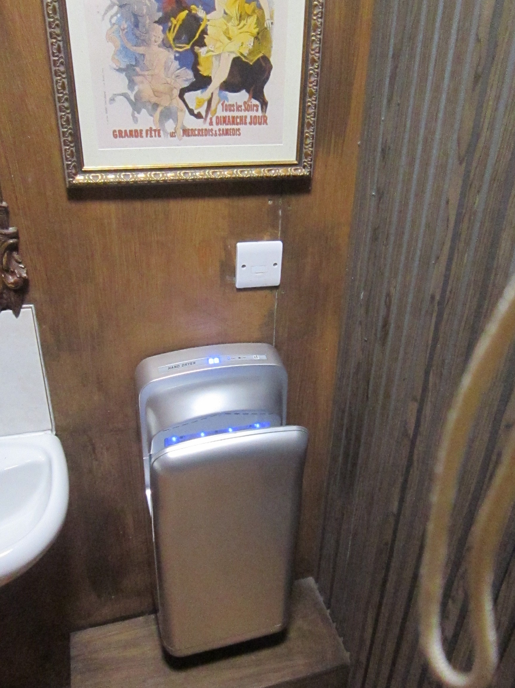
The nearest Changing Places Toilet is at Bristol Beacon. There is more information on the Changing Places Toilets website

Wheelchair and physical access
The exhibition space inside the main church is step free.

Auditory access
There is not a fixed induction loop at the venue.

Safety measures
There will be face masks and hand sanitiser available at the entrance to the main church.

Visual access

Large Print
All exhibition text will be printed at 18pt and above.
We will have a large print guide for the exhibition.

Audio Description
Staff looking after the exhibition can give an audio descriptive tour of the exhibition. If possible, email us beforehand to arrange a day and time: wearethepeople@bathspa.ac.uk.

Temperature of venue
The venue may be cold, so we would recommend bringing extra layers if you need them.

Sensory Access
There is not a separate quieter space available at the venue.
We will make one of the seating areas into a quieter/ rest area.

Pictures and descriptions of the main church
External doors leading into the entrance corridor.
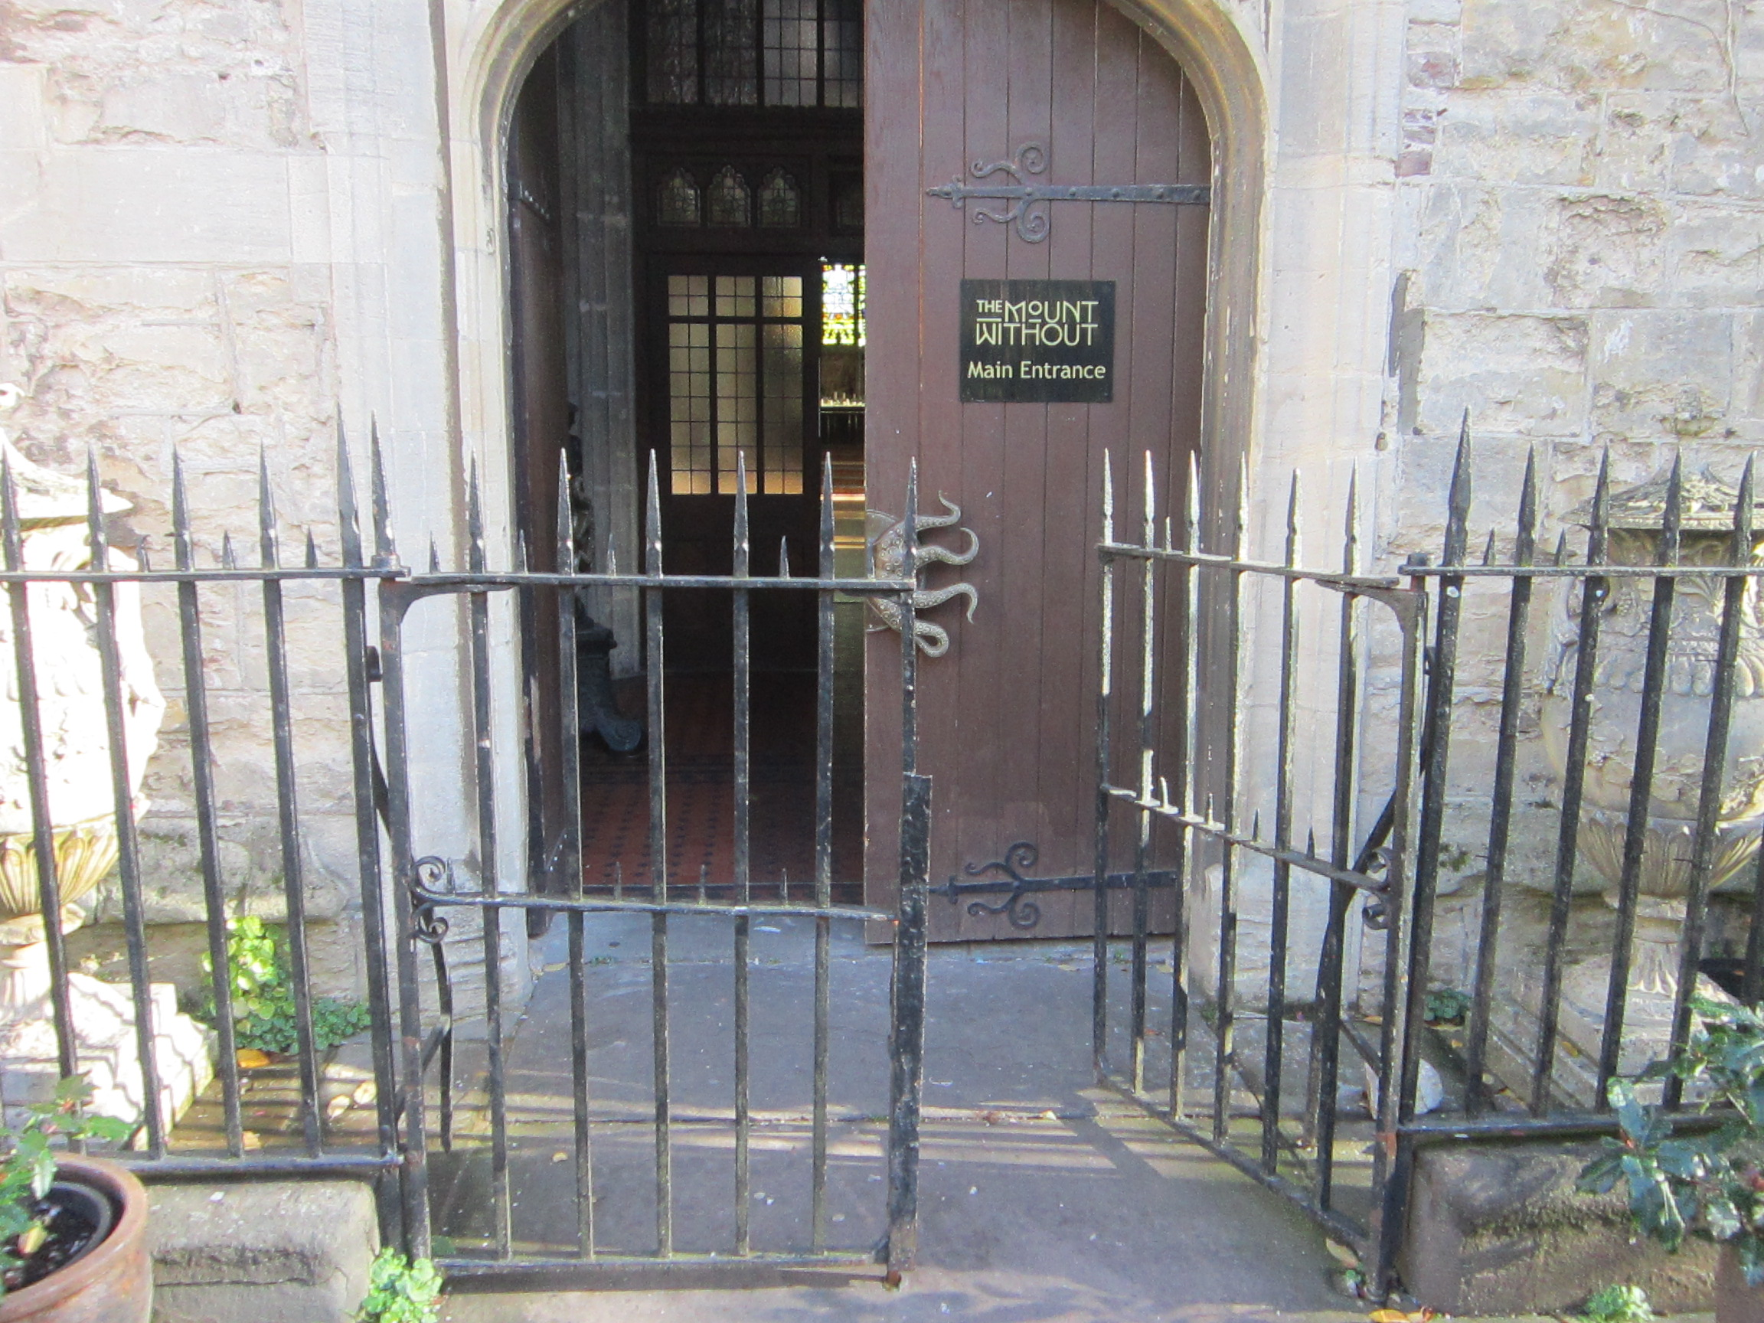
The entrance corridor leading into the main church, where the exhibition will be located.
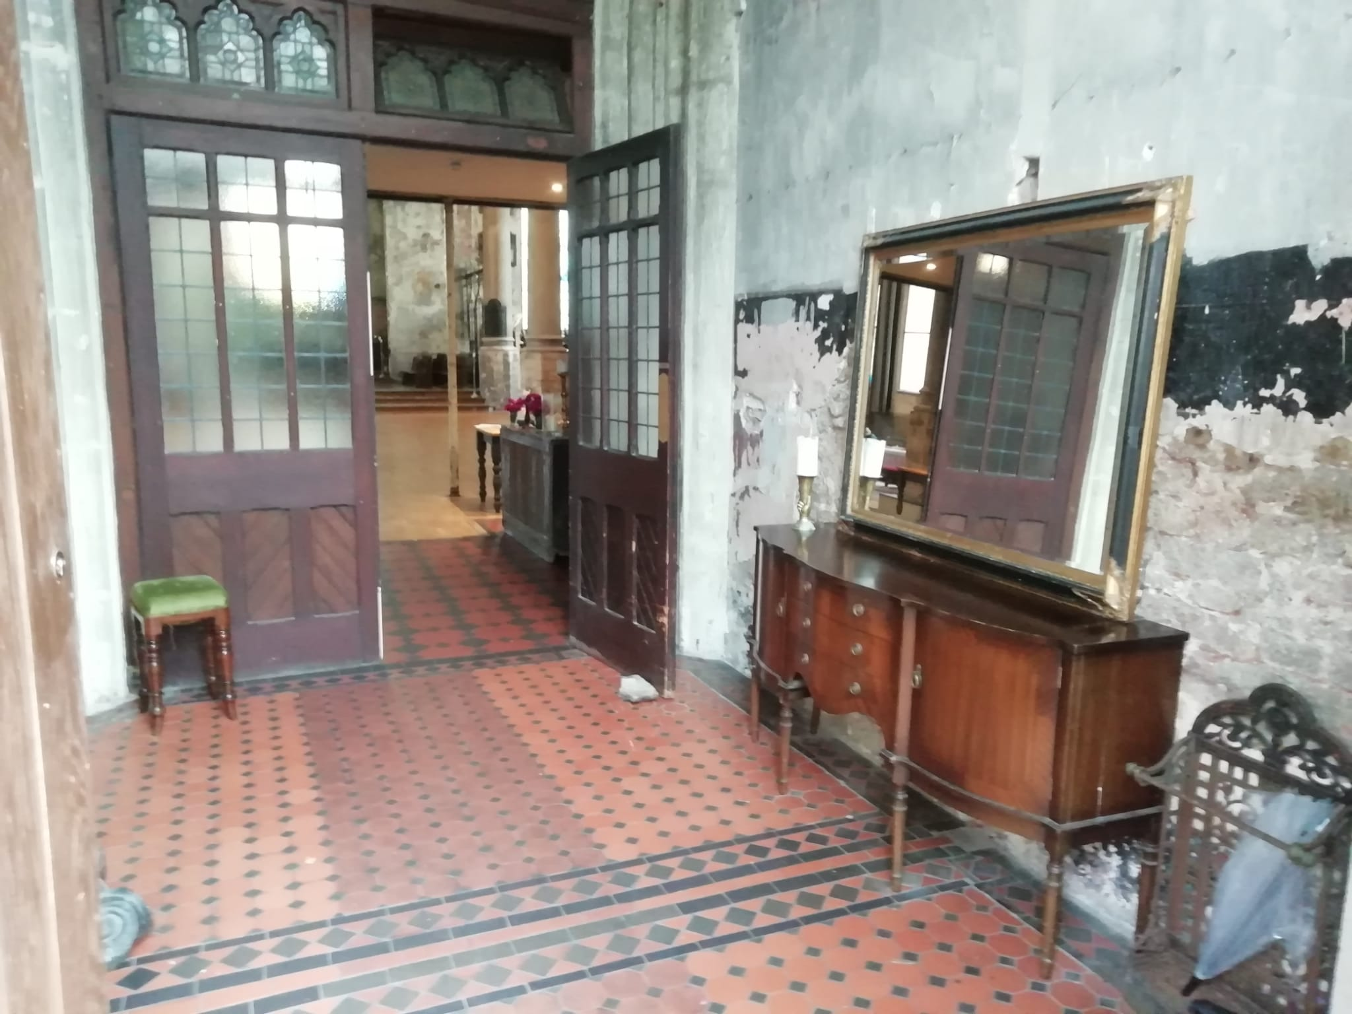
Doors leading into the main church.
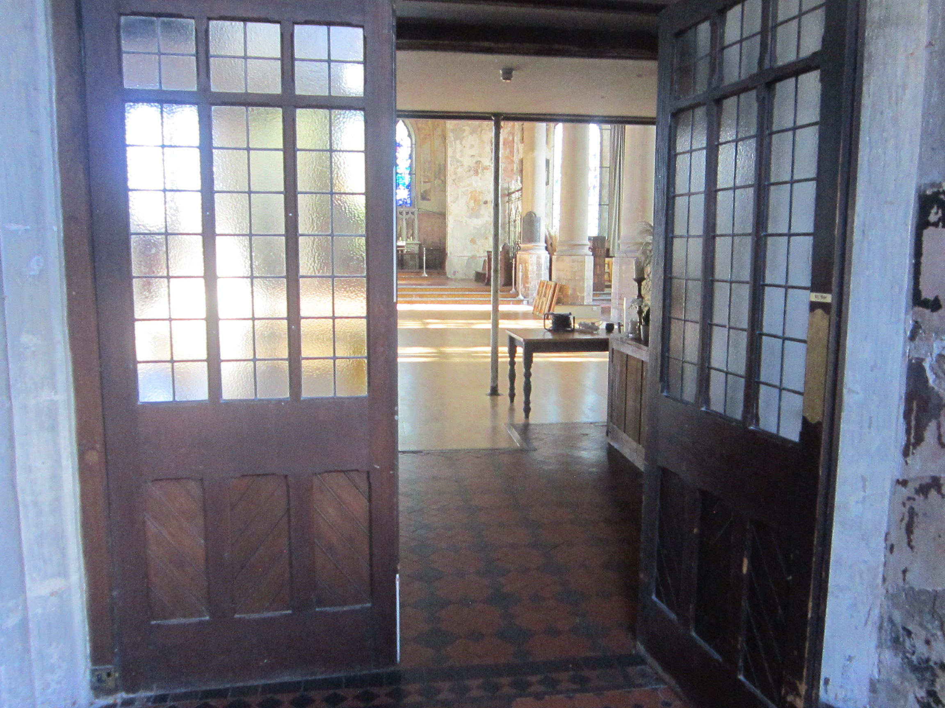
The main church space where the exhibition will be located.
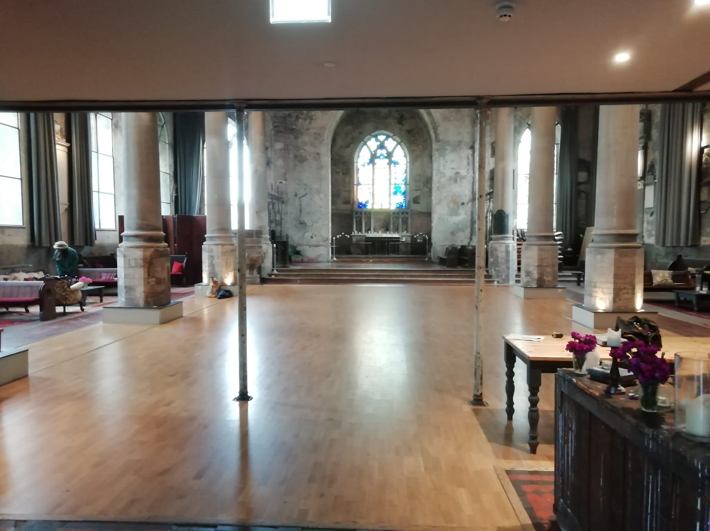
The area close to the doors, this is where the bar will be located for the evening event.
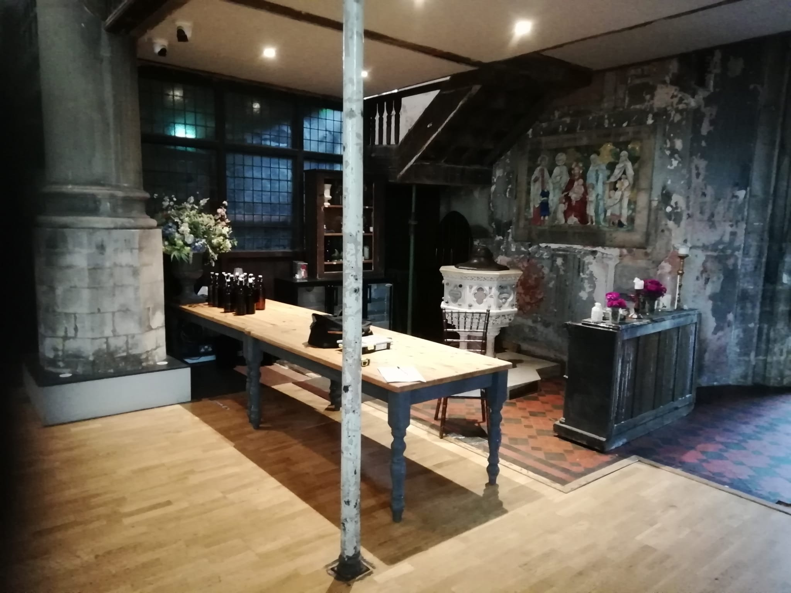
The toilets in the exhibition space.
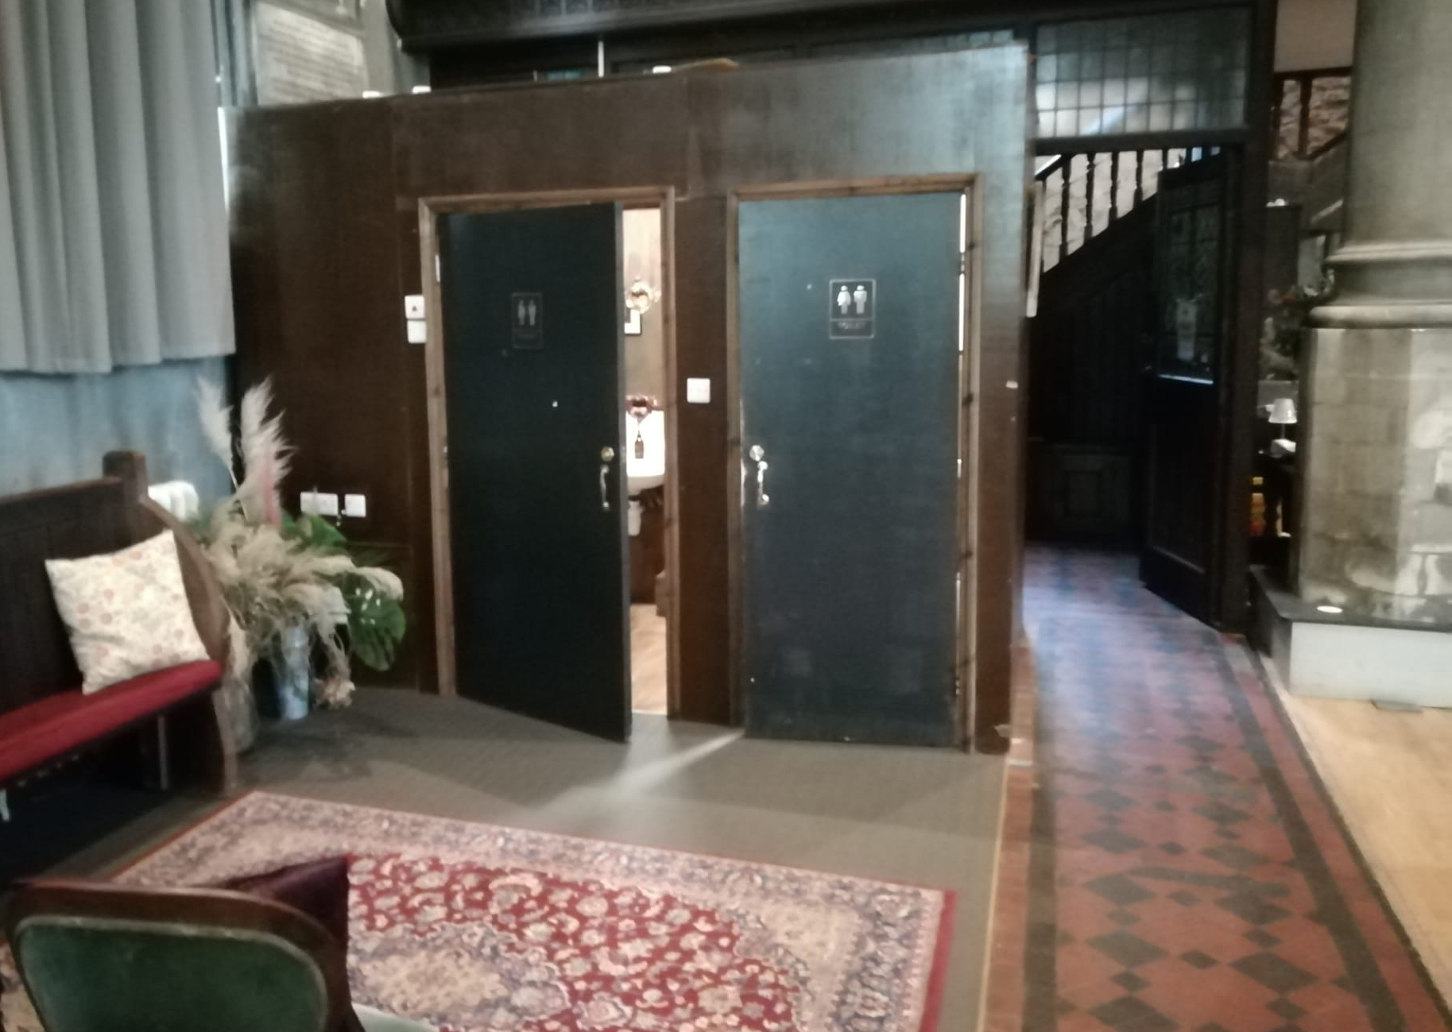
A view of the main church hall where the exhibition will be setup. The venue has high ceilings and there is lots of natural light that comes into the space through big windows on either side.
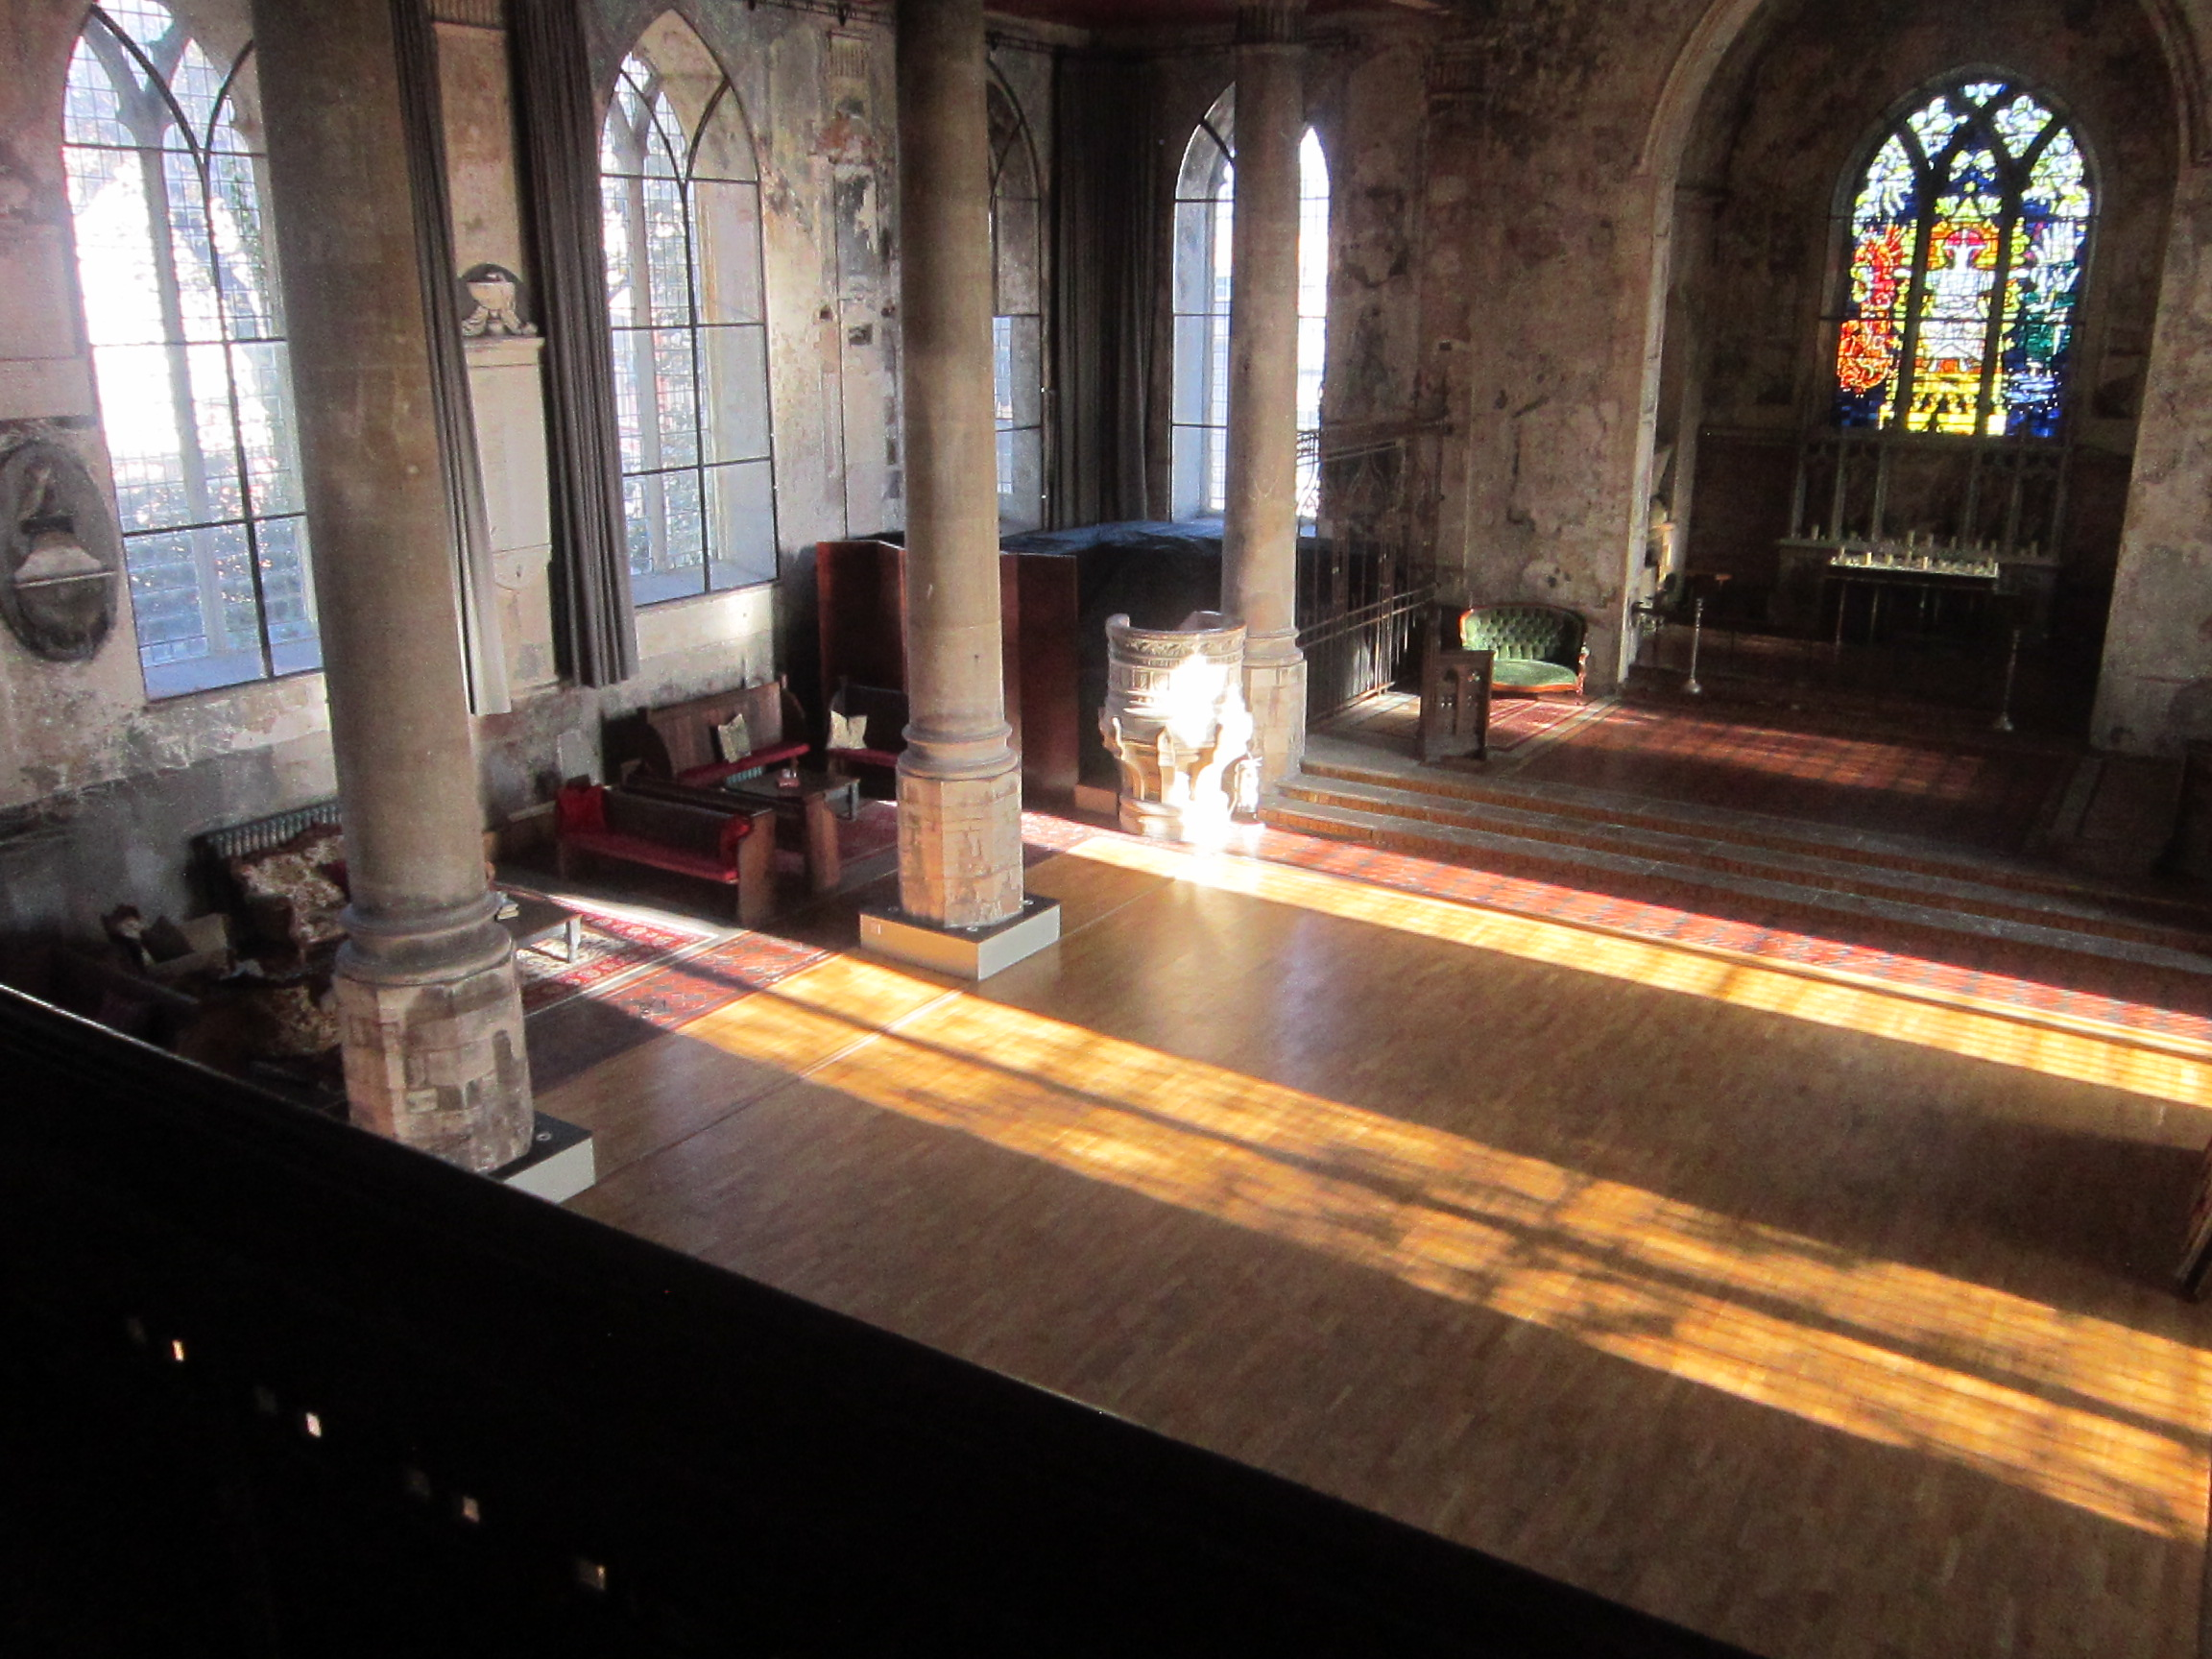
A view of the main church hall where the exhibition will be setup. There is a large sculpture hanging from the ceiling.
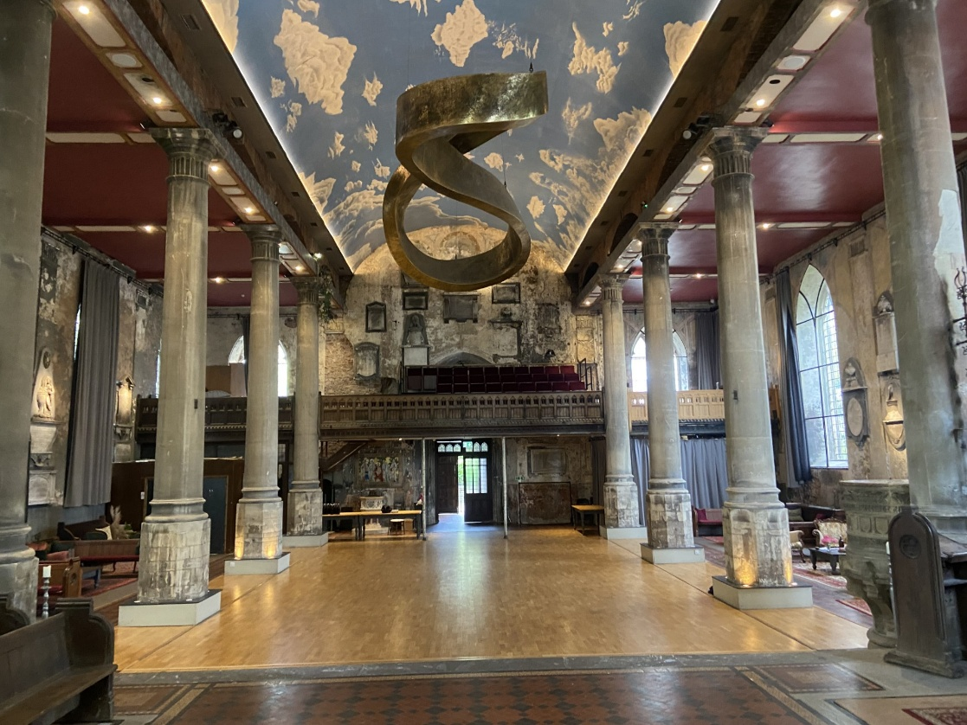
There are a variety of seating options in the space. We will position seating around the exhibition. If you need a chair to sit while exploring the exhibition, please let staff know and we can move it for you.
